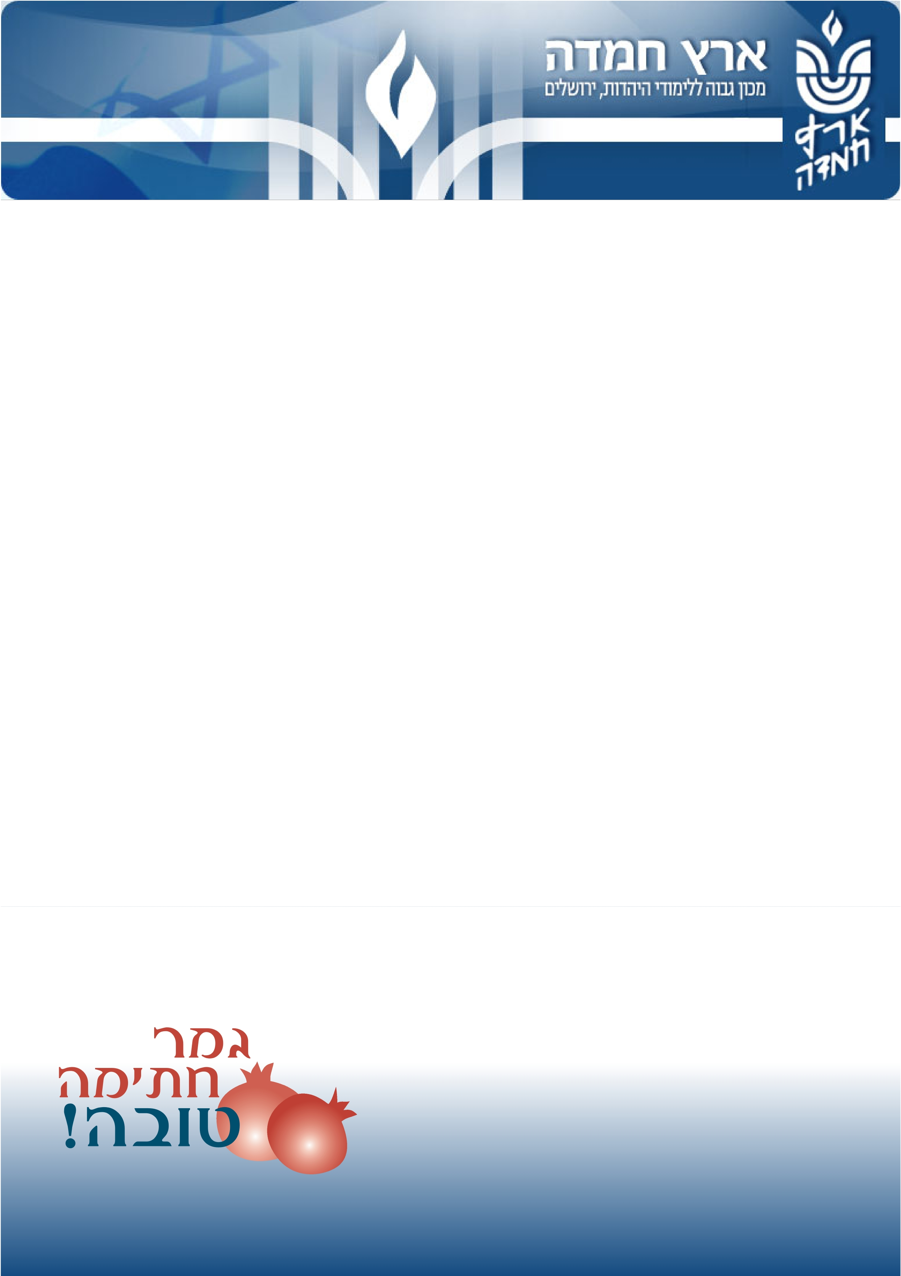

Tishrei 5770, September 2009
Dear friends,
The year 5770 marks 22 years from Eretz Hemdah’s inception. We are currently actively involved in the move to our new and spacious headquarters on Rabbi Chiyah Street in Jerusalem’s Katamon neighborhood. The complex will house a Beit Midrash, library, classrooms, offices, an international continuing education center, the national office of the Eretz Hemdah Gazit Beit Din network and its local Jerusalem branch.
The table below gives a visual account of our progress in the over two decades of our serving the Jewish People:

5748 Semester 5770 Semester
Young rabbis 16 44
Graduates - Over 100
Batei midrash in Israel 1 2
Becomea partner in continuing to build our success!לתרומות
Batei midrash abroad:

Financing a beit midrash
for rabbinical scholars in Rome, Italy
and Johannesburg, South Africa - 2

Volumes published of the responsa Bamareh Habazak - 7
Volumes published of Hemdat Haaretz - 7 Contact us
Volumes published of Living the Halachic Process - 2

Replies to questions from the public
within the framework of Ask the Rabbi - Over 15,000 queries

Viewing and downloading Torah thoughts
from our website - Over 2.5 million hits

Number of communities that ask halachic
queries to Eretz Hemdah - Over 250 communities

Copies of the Hebrew-language version
of Hemdat Yamim distributed weekly - Over 10,000

Copies of the English-language version
of Hemdat Yamim distributed weekly - Over 25,000

Board members 17 24
Branches of our Beit Din - 6
Employees 6 28
Your generous contribution assists us in continuing our work in creating future leaders of the Jewish People and promoting Jewish values worldwide.
May all of us merit raising the banner of Torah together in Israel!
We thank you in advance for all your help. May Hashem Bestow you with great reward for your endeavors.
Wishing you and your family a Gemar chatimah tovah,

Rav Moshe Ehrenreich Rav Yosef Carmel Shalom Wasserteil
Directors Chairman
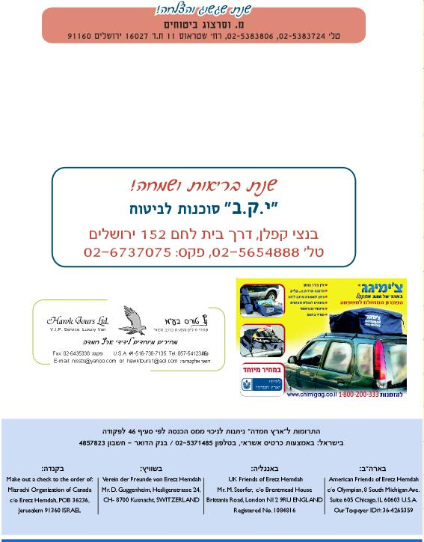
Become a partner in continuing to build our success!לתרומות

