
Yitro 17 Shevat 5771

By Will and by Force
Harav Shaul Yisraeli - from Siach Shaul, pg. 241

The gemara (Shabbat 88a) derives from the pasuk, “They stood at the bottom of the mountain” (Shemot 19:17) that Hashem actually held the mountain over them. Remember that this is after the whole discussion between Moshe and Bnei Yisrael and after Bnei Yisrael unanimously said “na’aseh v’nishma” (we will do and hear). Thus, it is unclear what changed that brought Hashem to coerce the nation to accept the Torah by saying that if they do not accept it, they would be buried under the mountain.
While many explanations have been said it seems to me that the following one has merit as well. There is a difference between the power that one has to decide something and the power he has to carry it out. Theoretically, these two powers are directly connected, as that which one wants, he carries out. However, in practice, there can be quite a distance between what one decides and what one does, as some good things remain a good wish and no more. Execution requires effort, sacrificing comfort, and overcoming difficulties, which are harder than just wanting something.
We remember well the days of the struggle against the British Mandate before the State of Israel was established. It was a very, very difficult struggle and included a tremendous amount of discomfort. However, the Jewish community stood up to the challenges in a very impressive way. The important thing to us was reaching the goal of statehood. In contrast, since the time we achieved independence, we often see laxness under pressure and a weakening of resolve, causing many goals to remain unachieved. It is not that it is impossible to achieve what we want, but that we have lost some of our stubbornness. What is behind the change?
The biggest difference is that then, as we used to like to say, we had a secret weapon called ein bereira (there is no alternative). As they used to say in the Navardok Yeshiva: “When you can’t do something, you have to do it; and when you have to, then you can do it.”
The same thing is true regarding the giving of the Torah. The saying of na’aseh v’nishma was fully sincere, but expressed only proper good will. However, Hashem knew human nature and knew that before too long Bnei Yisrael would be dancing around a Golden Calf, because there is a big distance between deciding and succeeding to carry out. It is easier to dance around a Calf than to “’kill oneself’ in the tent [of Torah].” It takes Divine Assistance, and that is what Hashem provided with a little bit of coercion, in the form of a “mountain over their heads.” He showed them that it is not only their desire to accept the Torah but that there is no other way. The entire existence of the Nation of Israel depends upon the extent to which they keep the Torah. This feeling of no alternative is what allows the good will to triumph in practice.
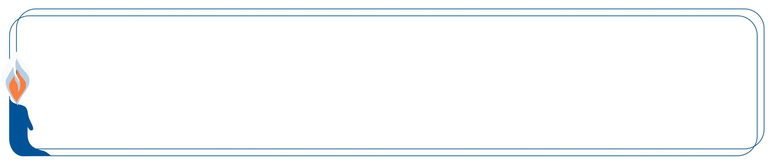

This edition of  Hemdat Yamim  is dedicated  to the memory of  R' Meir  ben Yechezkel Shraga Brachfeld o.b.m | Hemdat Yamim is  Dedicated  in memory of  Rina Bat  Yaakov Pushett A"H  Her smile  and warmth are sorely missed | Hemdat Yamim is dedicated  in memory of  Rivka Rozenhak  Yoseph and Bella Hirsch z”l  Passed away on  Tevet 3rd 5771 | Hemdat Yamim is dedicated in memory of  HaRav Professor Reuben M. Rudman  ob”m | Hemdat Yamim  is endowed by  Les & Ethel Sutker  of Chicago, Illinois  in loving memory of  Max and Mary Sutker and  Louis and Lillian Klein, z”l

Eretz Hemdah
Deans: Harav Yosef Carmel, Harav Moshe Ehrenreich
3 Rabbi Chiya Hagadol St. P.O.B 36236 Jerusalem 91360
Tel: 972-2-5371485 Fax: 972-2-5379626
Email: info@eretzhemdah.org web-site: www.eretzhemdah.org
Donations are tax deductable according to section 46 of the Israeli tax code
American Friends of Eretz Hemdah Institutions
c/o Olympian, 8 South Michigan Ave., Ste. 605, Chicago, IL 60603, USA
Our Taxpayer ID #: 36-4265359



Question: I toveled a big pot in the mikveh on a sideways angle. Some bubbles came out, but I am know that an air pocket remained. Do I have to redo the tevilla?

Answer: The mishna (Mikvaot 10:1) says that if one puts a kli (utensil) into a mikveh upside down, it is an invalid tevilla. This is due to the air pocket that prevents water from coming in fully. While this seems to invalidate your tevilla, a further look shows that matters are not so simple.
The Kiryat Sefer (Mikvaot 3) is unsure whether the above problem is that the water must come over the entire kli, in which case there is a Torah-level problem. The other possibility is that the problem is chatzitza (something that separates between the water and the object that requires tevilla). Regarding chatzitza there are two main parameters: whether it covers most of the object; whether it is makpid (one does not want to leave the chatzitza there indefinitely). When both factors are stringent, there is a Torah-level problem; when one factor is stringent, there is a rabbinic problem (Eruvin 4b). If the problem is that an air pocket is a chatzitza, since water touches the whole outside and some of the inside, the problem is at worst rabbinic and one must assume that it is considered makpid.
First, let us see if it is possible to require that the water touches the whole kli. If so, how could a chatzitza on a minority of the kli be fine from the Torah and permitted if one leaves it there forever? One approach is that in such cases, the chatzitza is batel to (undistinguishable from) the body/object, and it is as if the water touches everything (Sidrei Tahara, Yoreh Deah 198:1). However, the more convincing approach is that the water is required to touch only the majority of the surface, as long as the whole object is submerged and thus enveloped in water, and one has to deal with the issue of chatzitza (Chazon Ish, YD 95:3; see Badei Hashulchan 198:27).
According to the second approach, one could ask if something as “ethereal” as air can be a chatzitza. There seems to be a machloket whether something porous is a chatzitza. On one hand, mishnayot (see Mikvaot, ch. 9) indicate that liquid objects on a surface are not a chatzitza, whereas their dried-up counterparts are. Yet, the mishna (Mikvaot 10:6) says that tevilla on a barrel full of a not water-like liquid is invalid, and thus liquid must be a chatzitza. Tosafot (Zevachim 78b) says that a little liquid (the former cases) is permeable, whereas a barrel full is not (see Biur Halacha to OC 161:1). Others say that thick liquids are not considered permeable, and the reason some liquids are not a problem is that they are not considered makpid (Shach, Yoreh Deah 198:19; see Rama, YD 198:14). If so, an air pocket, which is not permeable when the kli is at certain angles, seems problematic.
At this point, any way we understand the mishna opposing upside-down tovelling should render the tevilla in question invalid. Yet, the Shulchan Aruch (YD 202:6) says that if the kli is somewhat wide, the tevilla is valid because water gets to its bottom. The Bach and Taz (ad loc.) argue that even wide pots can have air pockets, which experimentation and scientific analysis (we did both) corroborate. Perhaps Rav Yosef Karo assumed the following. There is not a need for water on the entire surface, and air does not function like a chatzitza. It is just that a type of tevilla that is not close to getting water throughout is not a proper tevilla. However, with a great width to height ratio, even when the angle is slightly off totally upside-down, water comes in fully, and it is easier for the water to get to any given spot with minimal swiveling. Thus, in those cases, it is considered a reasonable tevilla, and this likely applies to your case.
Since the simple reading of the sources indicates the tevilla was invalid, we suggest you to do tevilla again, but without a beracha. If it is difficult, there is some room for leniency (including for reasons beyond our present scope).

“Living the Halachic Process”
We proudly announce the publication of our second book in English.
“Living the Halachic Process volume II” a selection of answers to questions from our Ask the Rabbi project. A companion CD containing source sheets for the questions is also available.
In honor of the book’s debut, we offer it at the special rate of $25
Special offer: buy both volumes for the price of $40.

Contact us at info@eretzhemdah.org
Have a question?..... e-mail us at
info@eretzhemdah.org

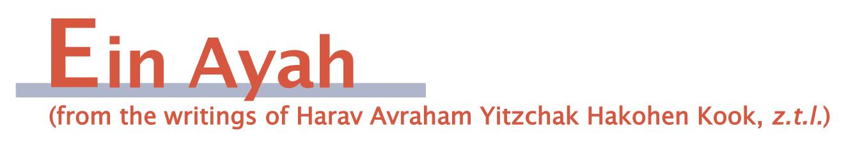
Doing Mitzvot Willingly
(condensed from Ein Ayah, Berachot 6:12)

Gemara: Come and see the difference between the earlier generations and the later generations. The earlier generations would bring their produce into the house through the main gate in order that they should be obligated in ma’asrot (tithes). The later generations would bring the produce in through roofs and side courtyards to exempt them from ma’asrot.

Ein Ayah: The following is a way to distinguish between those who recognize the lofty level of mitzvot and those who perform them as a matter of rote. Regarding many mitzvot of the Torah, there are effective steps that one can take to extricate himself from the obligation. It is in this regard that one can show whether he serves Hashem with love, namely, by forgoing the exemption and performing the mitzva because of its value.
The gemara demonstrates this idea in the context of a very appropriate mitzva. Ma’asrot is the main mitzva that strengthens the good fortune of the greater community, as it is at the heart of the covenant between the Tribe of Levi, which is set aside for the service of Hashem, and the nation as a whole. Therefore, the Divine Wisdom saw to it that it be fulfilled with a spirit of volunteerism by those who see its great value. That is why the Torah allowed a way to exempt oneself by bringing in the produce through side entrances so that the specialness of the mitzva is felt through volunteerism. This enables the whole community to be completed spiritually as Hashem desired.

A Land With Everything
(condensed from Ein Ayah, Berachot 6:15)

Gemara: [The words, “a tree of eating,” teach us that orlah (the prohibition of eating fruits during the tree’s first three years) applies to peppercorn, whose branches taste like its fruit.] This also teaches us that Eretz Yisrael is not missing anything, as the pasuk says: “A land where you will not eat bread out of deprivation, nothing will be missing from it” (Devarim 8:9).

Ein Ayah: This gemara shows the special level of shleimut (completeness) that Eretz Yisrael helps Bnei Yisrael reach. That is that not only will the acquisition of wealth and luxuries not damage their true spiritual shleimut, but it will actually add strength to their shleimut in the path of Hashem.
We are able to extrapolate the spiritual special quality of the Land from its physical uniqueness. Based on the natural makeup of peppercorns, we would expect them to be cultivable only in extreme climates, as the Midrash Tanchuma (Kedoshim 10) identifies Ethiopia as the classic place for them. Even so, Eretz Yisrael, which is in the middle of the inhabited world, does not lack even produce like that. We find a similar thing regarding the spiritual goodness that stems from all the wisdom of the world. We would expect some of that knowledge to be possessed only by certain other nations. However, these skills can also be found among the Jews of Eretz Yisrael (see Eicha Rabba 1:4).

Responsa B'mareh Habazak, Volumes I, II, III, IV, V and now VII:
Answers to questions from Diaspora rabbis. The questions give expression to the unique situation that Jewish communities around the world are presently undergoing. The answers deal with a developing modern world in the way of “deracheha, darchei noam”. The books deal with the four sections of the Shulchan Aruch, while aiming to also take into consideration the “fifth section”
which makes the Torah a “Torah of life”.
Special Price: 15$ for one book or
7 volumes of Responsa Bemareh Habazak for $90 (does not including shipping).
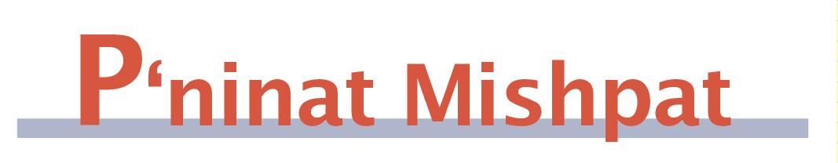

Paying for Construction Work That Was Destroyed by the Authorities
(condensed from Shurat Hadin, vol. III, pp. 282-289)

[The case presented is a complex one that has several elements to it. We have chosen to focus primarily on one element.]
Case: The plaintiff (=pl) sold property to the defendant (=def) along with an agreement that pl would build on it for def for a certain price. Work began, and def and pl decided to do further construction without approval from the relevant municipal authorities. In the midst of the construction, authorities halted the work and destroyed illegally built sections. While def paid pl partially as work progressed, pl makes a claim for outstanding payment for work and materials already provided.

Ruling: There is a machloket about how to relate to work that a kablan/ uman (craftsman, who is paid by the job, not by time) does and the payment due to him (Bava Kama 98b). One opinion views it as the worker working directly for the owner and automatically creating an obligation according to their agreement. The other opinion views the kablan as accumulating quasi-ownership in the object (uman koneh b’shevach kli = ukbsk), corresponding to the value of the improvements, and selling his part in the object to the owner for his wages due.
The Divrei Geonim (82:4) discusses a case where a kablan made improvements in fabric that his friend was preparing for a nobleman, but before he could return the object to his friend, the nobleman burnt the clothes in anger. He says that whether or not the kablan deserves to be paid for his work depends on whether ukbsk, as in this case the worker’s quasi-acquisition was destroyed. Since poskim are undecided on that matter (see Shach, Choshen Mishpat 306:30) the worker cannot extract payment from his friend out of doubt when he is not able to return the object, even if it was not his fault.
However, there are several opinions that hold that the machloket of ukbsk applies only to cases where the worker himself damaged the object after making improvements or to the matter of the worker having a lien on the object to receive his fees. According to the view that limits the machloket, both opinions regarding whether ukbsk agree that the worker acquires rights to his pay, which remain even if something (beyond the worker’s control) happens to the object (see Shach, CM 126:76). Some distinguish between cases where the object was destroyed in the midst of the work, in which case he does not yet deserve his pay, and where the work is completed and thus pay was due (S’ma 335:8; K’tzot Hachoshen 305:2).
Nevertheless def can rely on the opinions that pl does not deserve the money, so that money cannot be extracted from him. The matter is clearer in this case, where pl was aware that construction exceeded the permit and he should have thus made a condition that he demands to be paid even if the work is suspended or destroyed.
[The author of this ruling does not deal with the significant question of whether ukbsk applies to work done to land, as opposed to movable objects.]

Mishpetei Shaul
Unpublished rulings by our mentor, Maran Hagaon HaRav Shaul Yisraeli zt”l
in his capacity as dayan at the Israeli Supreme Rabbinical Court.
The book includes halachic discourse with some of our generation’s greatest poskim.
The special price in honor of the new publication is $20.

Do you want to sign your contract according to Halacha?
The Rabbinical Court, “Mishpat Vehalacha BeYisrael”
Tel: (077) 215-8-215 beitdin@eretzhemdah.org Fax: (02) 537-9626

Eretz Hemdah - Gazit serves the public in the matter of dispute resolution
according to the Halacha in a manner that is accepted by the law of the land.
While drawing up a contract, one can include a provision which assigns
the court jurisdiction to serve as an agreed upon arbitrator.

Eretz Hemdah is the premier institution for training young rabbis to take the Israeli Rabbinate's rigorous Yadin Yadin examinations. Eretz Hemdah, with its distinctive blend of Religious Zionist philosophy and scholarship combined with community service, ensures that its graduates emerge with the finest training,the noblest motivations resulting in an exceptionally strong connection to
Jewish communities worldwide.

