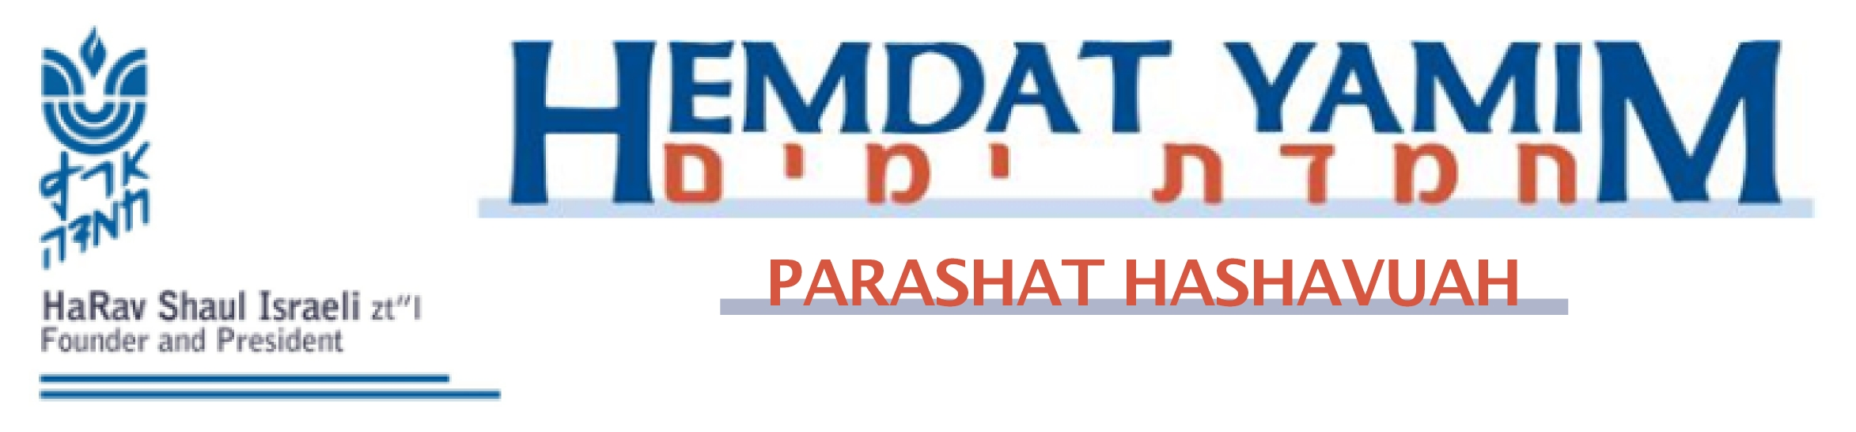
Terumah 5 Adar 5771

“Make for Me [an Aron] and I Will Dwell in Their Midst”
Harav Yosef Carmel

The description of the command to build the Mishkan, which dominates our parasha, starts in general terms, with building a Mikdash (Sanctuary) so that Hashem will dwell among [the people], which is made up of a structure and of vessels (Shemot 25:8-9). The first one is the aron (ark holding the tablets Moshe brought from Sinai).
The commandment to erect a mizbeach (altar) is found at the end of the parasha, after the command to make the Mishkan’s other vessels, its structure, its roof, and even its courtyard. Abarbanel was sensitive to this point and also raises the issue that the Torah says to build hamizbeiach (the altar), as opposed to the other vessels, which are written without the use of an article (e.g., an ark). He explains that “the” indicates that everyone was awaiting mention of the mizbeiach, since to people of that time, the main element of service of a deity was the bringing of sacrifices. This includes Adam and Noach, and also our great early leaders, such as the patriarchs and Moshe at the time of the giving of the Torah. So it is as if there is a known mizbeiach to which the word “the” refers to. Despite this, the Torah waits until close to the end to describe it.
David and Shlomo also saw the importance of the order, as we will explain. Both brought many korbanot when taking steps towards or actualizing, respectively, the building of the Beit Hamikdash. David did so when he uncovered the place where the Beit Hamikdash would stand (Shmuel II, 24:24-25), as stressed in Divrei Hayamim (I, 22:1), and when bringing the aron to Yerushalayim (Shmuel II, 6:12-13). Shlomo is described as bringing korbanot that were so many that they could not be counted (Melachim I, 8:4-5). Yet regarding building the Beit Hamikdash, it was not the mizbeiach that was stressed but the matter of the aron, especially in the way it was brought to Yerushalayim and brought to its permanent place (Melachim I, 6). Only in Divrei Hayamim does the building of the mizbeiach receive serious treatment, including regarding the descent of fire to the mizbeiach. In the writings of Chazal, as well, it is the moment of the bringing of the aron into the Mikdash that is described in exciting detail.
Our preoccupation with the aron, as opposed to the mizbeiach, also explains the halacha that when the aron leaves the area of the Mikdash, the Mikdash loses its status as the only place to bring a korban (Yerushalmi, Megilla 1:12). All of the above sends the following message. The dwelling of the Divine Presence, which is represented by the aron¸ is the main purpose of the sanctuary, not the ability to bring sacrifices. Let us pray for the restoration of the Mikdash and the fulfillment of the pasuk: “They will make for Me a sanctuary, and I will dwell in their midst” (Shemot 25:8).


This edition of  Hemdat Yamim  is dedicated  to the memory of  R' Meir  ben Yechezkel Shraga Brachfeld o.b.m | Hemdat Yamim is  Dedicated  in memory of  Rina Bat  Yaakov Pushett A"H  Her smile  and warmth are sorely missed | Hemdat Yamim is dedicated  in memory of  Rivka Rozenhak  Yoseph and Leah Hirsch z”l  Passed away on  Tevet 3rd 5771 | Hemdat Yamim is dedicated in memory of  HaRav Professor Reuben M. Rudman  ob”m | Hemdat Yamim  is endowed by  Les & Ethel Sutker  of Chicago, Illinois  in loving memory of  Max and Mary Sutker and  Louis and Lillian Klein, z”l

Eretz Hemdah
Deans: Harav Yosef Carmel, Harav Moshe Ehrenreich
3 Rabbi Chiya Hagadol St. P.O.B 36236 Jerusalem 91360
Tel: 972-2-5371485 Fax: 972-2-5379626
Email: info@eretzhemdah.org web-site: www.eretzhemdah.org
Donations are tax deductable according to section 46 of the Israeli tax code
American Friends of Eretz Hemdah Institutions
c/o Olympian, 8 South Michigan Ave., Ste. 605, Chicago, IL 60603, USA
Our Taxpayer ID #: 36-4265359


Question: May one get into a taxi on Motzaei Shabbat when the driver is a Jew who, in all likelihood, did not make Havdala, considering that it is forbidden to do melacha before Havdala?

Answer: The gemara (Shabbat 150a) tells of one who wanted to chop wood after Shabbat before Havdala and was allowed to do so only after reciting an informal Havdala (which we call Hamavdil). We accept the opinion that this declaration, that Hashem has distinguished between holy and mundane days, is recited without Hashem's Name (Shulchan Aruch, Orach Chayim 299:10). In any case, it is agreed that before some form of Havdala (full, in Ma’ariv, or Hamavdil) it is forbidden to do melacha. Therefore, you are, arguably, aiding one in transgressing, which is forbidden under the general category of lifnei iver (see Vayikra 19:14).
First we should note that the Rama (ad loc.) cites the opinion of Rabbeinu Yerucham that some melachot (e.g., lighting a flame and carrying) are permitted, and only more “complete” melachot are forbidden (e.g., weaving and writing). While the Rama prefers the stringent opinion, one would not be forbidden to enter a taxi if its driver is acting in a manner that is permitted according to a legitimate opinion. The Tzitz Eliezer (XI, 34) assumes that driving a car is the more serious type of work, which even Rabbeinu Yerucham forbids. This is not obvious, as the Taz (ad loc. 9) says that it depends if a person often will do it as a matter of course on Motzaei Shabbat, and many people drive on a regular basis after Shabbat (sometimes starting with returning from shul). Perhaps he is bothered by the taxi’s professional context.
The major discussion is about the nature of the prohibition of melacha before Havdala. Is it that the prohibitions of Shabbat continue until one ends them (similar to the fact that one can start Shabbat with a declaration on late Friday afternoon)? Or is it a separate matter that since there is a mitzva to honor Shabbat as it leaves with Havdala, it is wrong to commence work before doing so. Rashi (Shabbat 150a) and Rabbeinu Yerucham (see Taz, ibid.) seem to take the latter approach, and there are indications from the gemara that this is the correct outlook (see Divrei Yehoshua II, 108).
If it is a problem of postponing the mitzva and not transgressing a more standard aveira, then we have strong room for leniency. On a simple level, there are many sources that indicate that lifnei iver does not apply when the problem is somewhat weak or indirect (the gist of Shulchan Shlomo 299:15, in the name of Rav S.Z. Auerbach). Below we will cite a strengthened version of this idea. The Tzitz Eliezer adds an interesting twist. If the problem is the delay of the mitzva, then it does not apply to one who has no intention of doing the mitzva at all. He reasons that if we did not make that assumption, it would be forbidden at many times of day to feed non-daveners (even if they will make berachot) because it is forbidden to eat before tefilla. This observation could be reconciled according to Rav Auerbach’s observation as well.
Rav Shternbach (Teshuvot V'hanhagot II, 161) prefers the approach that there is a continued Shabbat prohibition. Yet, he says that lifnei iver does not apply because the taxi driver is continuing to do the same melachot that he was doing previously (this would not apply to a car service that works only when called). [Further development of the concept of lifnei iver on the Torah and rabbinic levels is beyond our scope]. The problem of the continued melacha approach may also be removed or mitigated by the practice of some (see Shemirat Shabbat K’hilchata, op. cit.) to get the driver to say “Shavua tov,” which might indicate his interest that Shabbat no longer be with him.
that it is permitted. We will discuss several explanations as to why.
For one or more of the reasons above, it should not be surprising that several poskim say (see Shemirat Shabbat K’hilchata 59:8) and standard practice is we think that one may call, hail, or get into a taxi with one who did not recite any form of Havdala.

“Living the Halachic Process”
We proudly announce the publication of our second book in English.
“Living the Halachic Process volume II” a selection of answers to questions from our Ask the Rabbi project. A companion CD containing source sheets for the questions is also available.
In honor of the book’s debut, we offer it at the special rate of $25
Special offer: buy both volumes for the price of $40.

Contact us at info@eretzhemdah.org
Have a question?..... e-mail us at
info@eretzhemdah.org

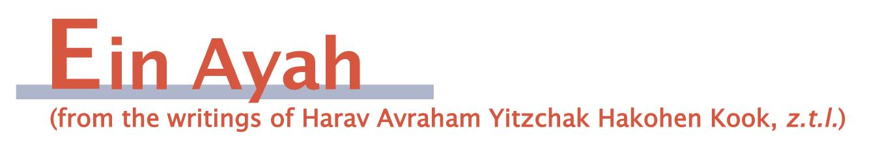
To Contemplate the Action or the One Who Acts
(condensed from Ein Ayah, Berachot 6: 18, 21)

Gemara: What does he say [as the beracha for bread]? “… hamotzi lechem min haaretz (the One who took out bread from the land.” Rabbi Nechemia says: “… motzi … (who took out ...). Rava explained: regarding motzi, everyone agrees that it means that He took out (Rashi – we require the beracha to be in the past, for Hashem already took this bread out of the land)… The halacha is to say “… hamotzi lechem min haaretz,” for we accept the opinion of the Rabbis, who say that hamotzi also refers to the past.

Ein Ayah: There are two possible ways to contemplate the greatness of Hashem in a manner that will bring a person to true love and awe of Him. One is to look in a scientific way at His complete actions, which are arranged in wisdom, kindness, justice, and straightness.
The second way is by having the scientific look lead to an emotional look, so that one yearns to love Hashem and be in awe of His loftiness and glory. It is true that by taking a scientific look, one does not normally come to understand Hashem’s essence. However, by allowing one’s heart to imagine and one’s spirit to desire, a coveting [of a connection] for the One who created all of these elements of nature can sprout forth.
The question is how a person should guide himself in this regard. Is it enough for a person to take an intellectual approach alone, allowing the internal excitement of the spirit to come on its own? Or, must he cognitively focus on the information with an eye toward creating a yearning for a connection to the very essence of Hashem’s glory that is loftier than any knowledge. Such a feeling cannot be known or calculated because it is beyond any calculation.
This is the difference between “hamotzi” and “motzi.” Motzi (who took out) relates to the One who acted only from the perspective of His action alone, without getting into His characteristics. This represents our being interested in recognizing the significance of the action alone (in this case, the development of the grain that was turned into bread). By saying hamotzi (the One who took out), with the letter ה serving as an article, we touch on the internal, emotional element of seeking out the glory of Hashem from the perspective of Hashem Himself who did the action. His actual glory is greater than all the grandeur we can picture by contemplating His actions alone. This understanding of the heart is an outcome of the internal light in the nature of the human spirit. It becomes activated when we remove the roadblocks that impede it, allowing it to naturally go up to its glorified place. This experience is referred to by such p’sukim as “My soul is thirsty for You; my flesh yearns for You” (Tehillim 63:2).
We accept the opinion that hamotzi also applies to the past, thus making it true to the simple, external meaning of the beracha, which is to thank Hashem for producing the grain. This is something that all people are able to relate to. Since one does not detract from this basic meaning, there is great gain to adding the ה, thereby arousing those who have wise hearts to contemplate the greatness of their Maker with as clear a view as they are capable of. In that way, they can jump from the action to the One who acted and from the past into the future.

Responsa B'mareh Habazak, Volumes I, II, III, IV, V and now VII:
Answers to questions from Diaspora rabbis. The questions give expression to the unique situation that Jewish communities around the world are presently undergoing. The answers deal with a developing modern world in the way of “deracheha, darchei noam”. The books deal with the four sections of the Shulchan Aruch, while aiming to also take into consideration the “fifth section”
which makes the Torah a “Torah of life”.
Special Price: 15$ for one book or
7 volumes of Responsa Bemareh Habazak for $90 (does not including shipping).
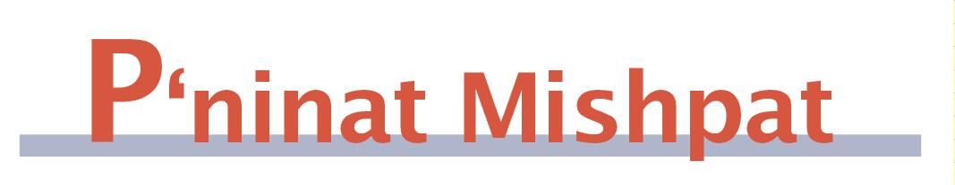
Refusing to Vote on a Ruling to Which One Objects
(based on Shurat Hadin, vol. VI, pp. 38-40)

[We continue, from last week, with an article that, one can say, deals with questions of democracy of a beit din panel. To what extent is one supposed to accept the decision of the majority and to what extent should one take unusual steps to try to force an outcome that he “knows” to be correct? Background to this section is that if one of the members of a panel says he does not know which side to the adjudication is correct, he is replaced by two others, who can arrive at a conclusion, and in theory could arrive at a different conclusion than the present majority (Sanhedrin 29a).]

The Shvut Yaakov (I, 138) was asked by a talmid chacham who was appointed to sit on a beit din with two ignorant men and saw that they are coming to an incorrect decision whether he could refuse to take a stand in order to force two dayanim to be added. He answered that although it would be lying to do so, since he has the noble intent of trying to prevent a travesty of justice, he may say he does not know. This is because one may distort a story in order to maintain peace.
In a similar case of three normal dayanim, the Beit Yaakov (15) says that one is not allowed to use such a trick. In citing the latter responsum and arguing, the Shut Yaakov says that a travesty of justice is a bigger problem than the value of the honor of the other dayanim. The Birkei Yosef (Choshen Mishpat 18:4) says that one cannot compare the different scenarios. The Beit Yaakov was talking about a case of a proper beit din, where one just strongly disagreed with the opinions of his colleagues. If one cannot convince the others of the superiority of his position, he cannot use a trick to prevent the ruling to be arrived at. However, the Shvut Yaakov discussed a case where the other two dayanim were ignorant people, in which case their ruling is not a legitimate one, and the Beit Yaakov would agree that one could say that he does not know. However, in the case of the legitimate beit din, the Birkei Yosef agreed that one could not take such a step. He implies, though, that the Shvut Yaakov would say even in that case that the lone legitimate dayan would be allowed to say he does know (the Urim V’tumim understood that way, as well). The Rav Pealim (III, 1) understood that the Shvut Yaakov would agree in the case of a legitimate beit din.
Rav Ovadya Yosef (Yabia Omer, CM 3) also understood that one should distinguish between the cases of legitimate and illegitimate dayanim. Thus, in the final analysis, in a normal beit din, a dayan must express his opinion accurately, even if, as a result, the other dayanim will overrule him.
[One would think that the explanation is that the single dayan may not reject the others as making an objective mistake. If so, if he has a way of “proving” to his friends that he is right but he knows that his proof is faulty, he should not falsely convince them, even if he thinks that his position is correct for a different reason.]

Mishpetei Shaul
Unpublished rulings by our mentor, Maran Hagaon HaRav Shaul Yisraeli zt”l
in his capacity as dayan at the Israeli Supreme Rabbinical Court.
The book includes halachic discourse with some of our generation’s greatest poskim.
The special price in honor of the new publication is $20.

Do you want to sign your contract according to Halacha?
The Rabbinical Court, “Mishpat Vehalacha BeYisrael”
Tel: (077) 215-8-215 beitdin@eretzhemdah.org Fax: (02) 537-9626

Eretz Hemdah - Gazit serves the public in the matter of dispute resolution
according to the Halacha in a manner that is accepted by the law of the land.
While drawing up a contract, one can include a provision which assigns
the court jurisdiction to serve as an agreed upon arbitrator.

Eretz Hemdah is the premier institution for training young rabbis to take the Israeli Rabbinate's rigorous Yadin Yadin examinations. Eretz Hemdah, with its distinctive blend of Religious Zionist philosophy and scholarship combined with community service, ensures that its graduates emerge with the finest training,the noblest motivations resulting in an exceptionally strong connection to
Jewish communities worldwide.

