
Vayakhel 22 Adar 5771

Shabbat – Our Personal Visit of the Divine
Harav Shaul Yisraeli - from Siach Shaul, pp. 296-7

Our parasha opens with Moshe telling Bnei Yisrael what Hashem had commanded in regard to the building of the Mishkan (Tabernacle). However, first it reiterates the commandment to refrain from forbidden work on Shabbat. There was a similar linkage between the Mishkan and Shabbat in Parashat Ki Tisa, at the end of Hashem’s commandment to Moshe about the Mishkan (Shemot 31:13), but here Shabbat is mentioned before everything.
Chazal (cited by Rashi, Shemot 35:2) learn from the linkage that despite the importance of the mitzva to erect the Mishkan, it did not justify desecrating Shabbat for that purpose. We can understand the philosophical significance of this halacha if we take into consideration the basic content of the mitzva of the Mishkan. According to several commentators, including Rashi, the mitzva originated only after the sin of the Golden Calf. The Seforno explains that originally Hashem just commanded, “An altar of earth erect for Me … to every place that I shall mention My name, I will come to you and bless you” (Shemot 20:21); after the sin they would need kohanim to make the berachot.
Let us put this in broader perspective in the following way. There is a phenomenon of naming a specific place for service of Hashem and a specific tribe to be involved in it, but this was not what Hashem preferred. It would have been better with a simple altar, without gold and silver or special kohanim with their special clothes. Rather, every Jew would be a kohen, the whole Land would be a Mikdash, and Hashem’s blessing would come everywhere. After the sin, everything had to be more specifically chosen.
However, as much as the means through which one reached the goal changed, the goal itself did not, and that is: “and I [Hashem] will dwell in their [the people’s] midst” (Shemot 25:8). All the Mishkan did was to create a point around which they would focus, where they could act and learn how to incorporate Hashem into their lives. The public Mikdash is not to replace the private one. Heaven forbid, one should never think that what he does in the Mikdash protects him from a sinful life that he leads outside of it. That was a real danger that the prophets, including Yirmiyah (7:9-10), warned about.
For this reason, the Torah felt it necessary to stress with the building of the Mishkan the matter of keeping Shabbat. The people must know that Shabbat, the personal spiritual constant that applies to every Jew wherever he is, still fully applies. The building of the Mishkan will not change that. While it was enough for Hashem to mention Shabbat after the commandment of the Mishkan, Moshe was afraid that when telling Bnei Yisrael about the MIshkan, they might get so carried away by the excitement that they would forget what Hashem truly wanted. It is for this reason that the Torah started off with the warning to keep Shabbat.
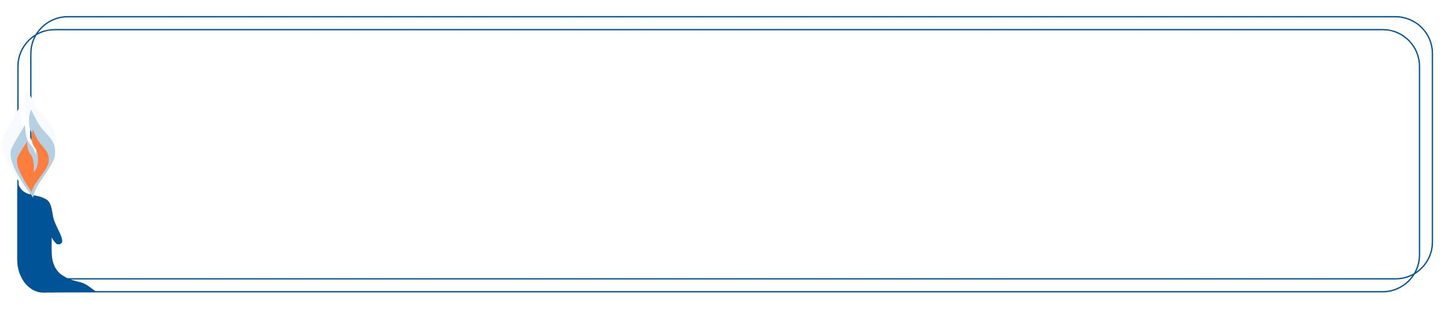

This edition of  Hemdat Yamim  is dedicated  to the memory of  R' Meir  ben Yechezkel Shraga Brachfeld o.b.m | Hemdat Yamim is dedicated  in memory of  Yehoshua ben Yaakov z”l (Egon Mayer)  By Ernest & Judith Gottdiener | Hemdat Yamim  is dedicated  in memory of  HaRav Professor Reuben M. Rudman  ob”m | Hemdat Yamim  is endowed by  Les & Ethel Sutker  of Chicago, Illinois  in loving memory of  Max and Mary Sutker and  Louis and Lillian Klein, z”l

Eretz Hemdah
Deans: Harav Yosef Carmel, Harav Moshe Ehrenreich
2 Bruriya St. corner of Rav Chiya St. POB 8178 Jerusalem 91080
Tel: 972-2-5371485 Fax: 972-2-5379626
Email: info@eretzhemdah.org web-site: www.eretzhemdah.org
Donations are tax deductable according to section 46 of the Israeli tax code
American Friends of Eretz Hemdah Institutions
c/o Olympian, 8 South Michigan Ave., Ste. 605, Chicago, IL 60603, USA
Our Taxpayer ID #: 36-4265359


by Rav Daniel Mann

Question: My roommate (=Reuven) and I disagreed whether it is necessary to lock our dorm rooms when leaving, and he often does not bother or remember to do so. Recently, things were stolen from our room after he left it unlocked. I think he should pay, as his approach was proven overly optimistic at my expense. Am I right?

Answer: First, let us see whether Reuven, who as a roommate was able and arguably responsible to help guard your items, when applicable, should be obligated as a negligent shomer (watchman). One does not become obligated as a shomer unless he accepts responsibility, which probably did not happen in your case. It is not sufficient to be aware that the object’s owner left the object in his proximity (Bava Metzia 81b).
Yet, there may be grounds for obligation as a shomer, as follows. The Rambam (Sechirut 2:3) says that even in cases (such as guarding land) where the laws of a shomer do not apply, one is still obligated to pay for negligence because “negligence is like damaging.” We can suggest similarly that the negligence of not locking the door obligates one even if he does not do a damaging act and he does not have the obligations of a shomer. True, commentators (see Shach, Choshen Mishpat 66:126) say that this is true specifically to one who accepted being a shomer, as the moral obligation to watch exists, just without a shomer’s halachic obligations. Thereby one who fails to guard on the most basic level must pay. However, in our case, he never promised to guard. Yet, our case is more stringent, as roommates have a relationship of interdependency and responsibility (e.g., if you had complained to the school, they probably would have instructed Reuven to lock the door). Therefore, the Rambam’s opinion should apply to this case. Regarding halacha, the Shulchan Aruch and the Rama (Choshen Mishpat 301:1) cites the Rambam’s as the minority opinion, while the Shach (op. cit.) accept his opinion. In short, it is unlikely that a beit din would extract money from Reuven based on this logic, despite its significant merit.
Another avenue to explore is damages. The gemara (Bava Kama 55b) says that if one breaks his friend’s flimsy wall that was holding back his friend’s animal, beit din cannot make him pay, but he has a moral obligation to do so. There is a machloket whether he is forced to pay when he knocked down a strong wall causing the animal to get lost (see Shulchan Aruch, CM 396:4). The Yam Shel Shlomo (Bava Kama 6:3) says that even one who obligates there does so because felling the wall that holds back an animal is like removing the animal. In contrast, one who opens a door that allows a thief to come in, only introduces a new, potential damaging factor. The latter is gerama (indirect damage) and one is not obligated, although there is likely a moral obligation to pay (gemara, ibid.). Our case is even more lenient, as Reuven has every right to open the door, and the problem is his failure to lock it later (it might depend if he purposely did not lock it).
A final category, which is a mix of the two above, is nizkei scheinim (damages among neighbors). The Tur (CM 157) cites a machloket. The Ramah compares the case of a neighbor who warns another that his failure to close a door allows robbers in to the case where one warns his friend that his wall fell and the mingling of their different vegetations will render them forbidden and he does not act, where he must pay (Bava Kama 100a). The Rosh counters that in the latter case, the mechanism that creates the prohibition begins working immediately, which is different from the possibility that robbers may come from elsewhere to damage. The Rama (CM 155:44) cites both opinions regarding one neighbor who asked the other to remove an indirect damager and he did not. In our case, then, it is hard to extract money but also hard for Reuven to wipe the slate clear. Therefore, we think it is proper for you to suggest a compromise with Reuven about payment and have him accept the responsibility to lock the door seriously in the future.

“Living the Halachic Process”
We proudly announce the publication of our second book in English.
“Living the Halachic Process volume II” a selection of answers to questions from our Ask the Rabbi project. A companion CD containing source sheets for the questions is also available.
In honor of the book’s debut, we offer it at the special rate of $25
Special offer: buy both volumes for the price of $40.

Contact us at info@eretzhemdah.org
Have a question?..... e-mail us at
info@eretzhemdah.org

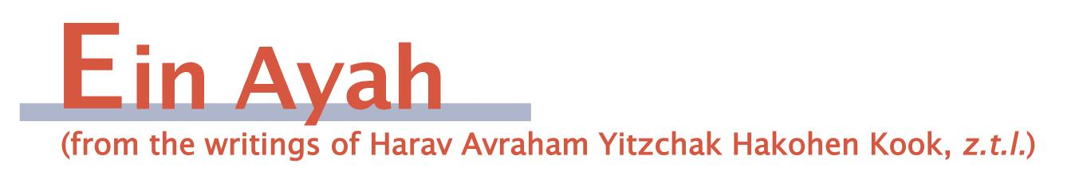

The Right Balance in Food and Torah
(based on Berachot 6:29)

Gemara: One who “immerses” his food in water will not come to intestinal problems.

Ein Ayah: It is proper to become aware that in the matter of spiritual sustenance, as regarding physical food, there must be a proper balance. We have already stated that bread is a metaphor for halacha. It is dry, but it is also the foundation of our nutritional sustenance. However, to do its job, it requires water to enable it to be digested and spread throughout the body as part of the life-giving blood stream.
So too, in the spiritual realm, aggada (hinted at by water) serves to reveal the good effects that the knowledge of and involvement in halacha has. Actually, any true knowledge, even if it is “dry” and shares nothing with the “spiritual logic” that straightens one’s personality and uplifts the soul, helps complete the spirit. The positive impact is actualized when the knowledge is accompanied by the spiritual wisdom and fear of Hashem. These can reveal the way the knowledge makes spiritual impact and purifies a person’s characteristics.
This is all the more true regarding the directly holy knowledge of Torah. Aggada complements the intensive study of halacha, enabling one to extract the desired results from it. Without the study of aggada, which enables the learner to taste fear of sin and love of Hashem, the “dry knowledge” would remain “undigested” and cause “intestinal illness.” There is such a phenomenon in the physical world, and, through its metaphor, in the spiritual world.
It is important to find the right balance between the areas of Torah study. [We skip over Rav Kook’s technical dealing with the gemara’s various commentators regarding the metaphor]. It is possible that someone who is already a giant in Torah and has “filled his stomach” with practical knowledge will choose to elevate his spirit by focusing primarily on Divine concepts that are at the root of the words of aggada. It is these that are the goal of man’s self-completion and the road that leads him to salvation from pain and the evil inclination.

The Limits of Remembering Death
(based on Berachot 6:30)

Gemara: One who is used to eating lentils once in thirty days prevents askara (a painful, lethal disease). However, he should not eat lentils every day because it causes bad breath.

Ein Ayah: This teaches a moral lesson because lentils are a classic food for mourners. In the spiritual realm, there is reason to periodically remind oneself of the fact that death is part of life. Fear of punishment is also a healthy thing, as it dampens one’s spirit in a manner that distances him from haughtiness, which causes him to forget Hashem.
However, one should use this tool of rebuke only periodically. On a daily basis one should use the higher level of spiritual encouragement, based on love of goodness and righteousness, according to the pleasantness of Hashem. This is because over-reliance on the simple but harsher tool of fear of punishment causes sadness or craziness and puts bad ideas into the heart. A person can be complete in his views and characteristics only when his spirit is happy, which widens the mind and raises the heart in fear of Hashem. A subdued spirit lowers a person, and the words of Torah will no longer be sweet to him. The metaphor of bad breath is appropriate because in that state one cannot taste the food’s appeal, and he will be missing the spiritual sense of a good smell. The same idea applies in the spiritual realm. Therefore one should not overuse the harsh rebuke of remembering death to fight the evil inclination.

Responsa B'mareh Habazak, Volumes I, II, III, IV, V and now VII:
Answers to questions from Diaspora rabbis. The questions give expression to the unique situation that Jewish communities around the world are presently undergoing. The answers deal with a developing modern world in the way of “deracheha, darchei noam”. The books deal with the four sections of the Shulchan Aruch, while aiming to also take into consideration the “fifth section”
which makes the Torah a “Torah of life”.
Special Price: 15$ for one book or
7 volumes of Responsa Bemareh Habazak for $90 (does not including shipping).
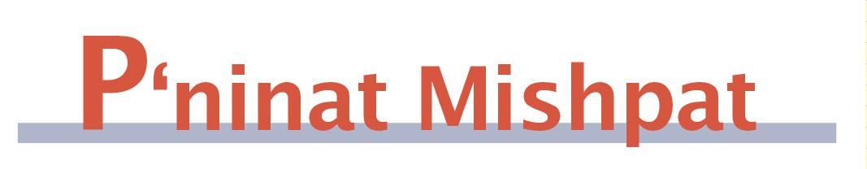
Forcing Someone With a Rare Blood Type to Donate
(based on Shurat Hadin, vol. VI, pp. 201-208)

May health authorities force one who has a rare blood type to donate blood? The question can be asked when there is a specific person in need of the blood or when there is a general shortage of that type in the blood banks, in such a way that there is a statistically high chance that such blood will be needed and unavailable.
The Tur (Choshen Mishpat 426) rules that one who sees someone is endangered by drowning or by the approach of a bandit is required to save him whether it requires use of his body or his property, just that the person in danger is required to reimburse him if possible. The question, though, is: is the requirement only a moral obligation or can he actually be forced to save?
The gemara (Ketubot 86a) says that while there is a set number of lashes given to those who violated certain negative commandments, one who refuses to fulfill a positive commandment can be hit until he complies. According to Rashi (ad loc.) the distinction is not between positive and negative commandments but depends on whether there is still an opportunity to fulfill the obligation, in which case force is not limited. Thus, if one is planning to violate the matter of standing idly by while a friend is in danger, he can be coerced as necessary to save. Our case is clearer than the case of a positive commandment, as one may and must do almost anything to save a life. It appears from the Tur’s description of bandits that the danger does not have to be very specific.
Do we have to take into account the potential danger to the blood donor? At first glance, we see that tens of thousands of people donate blood, and we do not hear of people who are endangered by it. It is true that some people say they are afraid of the consequences, but these appear to be unlearned complaints, for the most part provided by those who are lazy or have a fear of the pain or the process. (If someone has a rare sensitivity to donating blood, so that there is even a small danger, he is not required to donate. Although the Yerushalmi (see Beit Yosef 426) says that one is required to place himself in possible danger to save someone from definite danger, that opinion is not accepted- see Radvaz III, 627).
The Tzitz Eliezer (XVI, 23) says that one is not required to donate blood for the following reasons: one is required to provide effort and money in order to save, but we do not find that he has to give his life blood; people do faint or undergo extreme fright from the prospect of giving, and there are sources about people dying from scratches and gemarot about the dangers of bloodletting. Therefore, he says, donating blood is a righteous but voluntary act. It is easy to argue with the Tzitz Eliezer because the sources he refers to relate to hemophiliacs or to the type of procedures that are no longer done.
Therefore, in a case where participation of a specific person in blood donation is of particular urgency and there is no special reason to suspect danger for him, he can be coerced if necessary to give. Practically, it is much wiser and more appropriate to appeal for his agreement or to offer positive incentives.

Mishpetei Shaul
Unpublished rulings by our mentor, Maran Hagaon HaRav Shaul Yisraeli zt”l
in his capacity as dayan at the Israeli Supreme Rabbinical Court.
The book includes halachic discourse with some of our generation’s greatest poskim.
The special price in honor of the new publication is $20.

Do you want to sign your contract according to Halacha?
The Rabbinical Court, “Mishpat Vehalacha BeYisrael”
Tel: (077) 215-8-215 beitdin@eretzhemdah.org Fax: (02) 537-9626

Eretz Hemdah - Gazit serves the public in the matter of dispute resolution
according to the Halacha in a manner that is accepted by the law of the land.
While drawing up a contract, one can include a provision which assigns
the court jurisdiction to serve as an agreed upon arbitrator.

Eretz Hemdah is the premier institution for training young rabbis to take the Israeli Rabbinate's rigorous Yadin Yadin examinations. Eretz Hemdah, with its distinctive blend of Religious Zionist philosophy and scholarship combined with community service, ensures that its graduates emerge with the finest training,the noblest motivations resulting in an exceptionally strong connection to
Jewish communities worldwide.

