
Metzora 5 Nissan 5771

Watch Out for the Sinner’s … Feelings
Rav Daniel Mann

The Torah (Vayikra 14:13) says that the korban asham (guilt offering) that the metzora (“halachic leper”) brings upon being purified is slaughtered in the same place as the chatat and olah offerings (to the north of the altar). Chazal (see Rashi, ad loc.) ask that this seems superfluous, as all korbanot asham are slaughtered in this place. The answer that Rashi cites is that since there is a process of standing the metzora and the korban by the opening of the Mishkan, which is unique among ashamot, we might think that the place of the slaughtering would also be different.
Rav Neventzal gives another answer, with the help of the gemara (Sota 32b) that explains why the chatat and olah are done in the same place. The gemara says that it is so those who are not intimately involved in the korban will not know whether he is bringing a voluntary korban or whether he sinned and needs atonement. Rav Neventzal posits that we might think that this is not true for a metzora, whose sin that is classically responsible for his physical/spiritual disease is the damaging lashon hara. Yet, stresses the Torah, his dignity, too, is to be preserved as much as possible.
Is a metzora really awarded such privacy?! After all, he must sit outside of the encampment and when people approach him, say “impure! impure!” (Vayikra 13:45-46). We can suggest at least two answers. A simple one is based on the understanding of the gemara (ibid.) that his calling out is for his own direct good, to make people feel bad and seek Divine mercy for him.
However, a second answer may give a little insight into the educational process the Torah employs in his regard. On one hand, while he is in the midst of paying for his crimes and introspecting on his lot, he is to realize the severity of his actions and the unwillingness of religious society to allow such behavior to go on in their midst. However, when his physical status improves and indicates the end to his suffering, he is to be welcomed back in a manner that gives him hope to reenter society as a respected person whose sins are behind him in the eyes of all.
This is similar to the person who requires the punishment of malkot (lashings). The Torah tells that once he has received his allotted number, it is strictly forbidden to add even one more lashing (Devarim 25:3). As a matter of fact, this pasuk is the source for the prohibition to hit anyone. The pasuk continues that if one hits him extra, then “your brother will be defiled before your eyes.” Rashi points out: “All day long he is called a rasha, and after he is lashed, he is called your brother.”
While no one should enjoy it, there is sometimes a need, in different forms under different circumstances, to punish someone. However, the Torah wants us to remember that we want to get the person to the point where he becomes a full member of society. He should be able to earn back the respect of others and, no less importantly, self-respect.
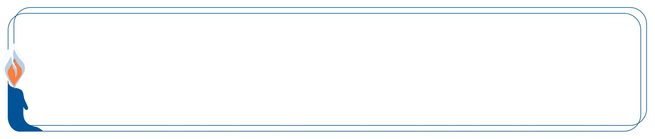

This edition of  Hemdat Yamim  is dedicated  to the memory of  R' Meir  ben Yechezkel Shraga Brachfeld o.b.m | Hemdat Yamim  is dedicated  to the memory of  Gershon (George) ben Chayim  HaCohen Kaplan  o.b.m. | Hemdat Yamim  is dedicated  in memory of  Nachum Eliezer Ra'anan  ben Yosef HaCohen (Larry Roth) o.b.m  who passed away on the 21th of Adar. | Hemdat Yamim  is dedicated  in memory of  Yehudah  ben  Naftali Hertz Cohen (Kamofsky)  o.b.m. | Hemdat Yamim  is endowed by  Les & Ethel Sutker  of Chicago, Illinois  in loving memory of  Max and Mary Sutker and  Louis and Lillian Klein, z”l
Eretz Hemdah
Deans: Harav Yosef Carmel, Harav Moshe Ehrenreich
2 Bruriya St. corner of Rav Chiya St. POB 8178 Jerusalem 91080
Tel: 972-2-5371485 Fax: 972-2-5379626
Email: info@eretzhemdah.org web-site: www.eretzhemdah.org
Donations are tax deductable according to section 46 of the Israeli tax code
American Friends of Eretz Hemdah Institutions
c/o Olympian, 8 South Michigan Ave., Ste. 605, Chicago, IL 60603, USA
Our Taxpayer ID #: 36-4265359


by Rav Daniel Mann

Question: Should one follow the minhag to put out ten pieces of bread before bedikat chametz? I have heard people question the minhag’s logic.

Answer: The minhag is old, mentioned (and rejected) by the Ra’avad over 800 years ago as a safeguard that the beracha on the bedika should not turn out to be l’vatala (in vain) if nothing is found. The concern seems to assume that the beracha is for finding chametz. There are at least four explanations of this beracha, which is al bi’ur (on the destruction or the removal of) chametz, which is strange because it is made before the bedika, not the burning, which is the next day: 1) This is the beginning of the preparations for the main event, the next day’s bi’ur (Taz 432:4); 2) The beracha is primarily on the mitzva (perhaps rabbinic) to search for chametz (see Rosh, Pesachim 1:10); 3) The beracha includes the bitul (nullification) done after the bedika (see ibid.); 4) The beracha is primarily on the removal of the chametz from one’s mind, which happened before the bedika started (Rambam, Berachot 11:15). The problem of beracha l’vatala if no chametz is found (but known chametz will be disposed of tomorrow) is only according to the second approach and assuming that the search must turn up something. Yet, it is reasonable for a minhag to deal with a possible problem even if the concern is based on a minority opinion, and this is the simple reading of the Rama (Orach Chayim 432:2).
Some Acharonim reject the rationale and the practice of the minhag. The Taz (op. cit.) says that not only is it unnecessary but it is detrimental because one might not find everything that was put out. This concern is mitigated by the usual care of whoever puts them out to know the number (traditionally, ten) and location of the pieces. Irrespective of this minhag, it is always possible that chametz will be missed and after doing bedika and bitul, one is not culpable (see Living the Halachic Process, vol. I, D-16). Some suggest to make pieces of less than a k’zayit so that if he misses one, there will not be enough to violate the prohibition of possessing chametz (Zera Emet I, 48; Yechaveh Daat V, 31). An interesting practical machloket is whether people will take bedika more or less seriously due to the presence of the ten pieces, and it may depend where they are placed (see Chok Yaakov 432:14, Ish Matzliach I, OC 37).
Other reasons are given for putting out the pieces of bread. The Mahari Weil (193) cites the gemara’s concern that something prompt one to do bitul, and says that the best reminder is to finish bedika by putting everything found away for the next day’s burning and then doing bitul. Another factor makes the minhag particularly appropriate in our times. Classically, people had much smaller houses and less property, and bedika was the main Pesach cleaning. Now people spend weeks cleaning seriously in a manner that makes the bedika (almost) a formality, in which they do not look for real chametz. (See Ask the Rabbi, Vayikra 5766 for a discussion of whether this is justified.) Without the pieces of bread, then, the bedika is neither a preparation for burning nor a serious search, and the beracha is more problematic (Emek Halacha, cited by Kaf Hachayim 432:31). There are also Kabbalistic reasons, attributed to the Ari, for the minhag. (See the Tzitz Eliezer’s (IX, 17) proof that looking for something that you know is there is considered searching in our context.)
Although there have been, over the centuries, poskim who thought that this minhag is superfluous or detrimental, one should follow it unless he has specific reason not to. (Minchat Yitzhak VIII, 35 says that the minhag does not apply to one who is doing a “pre-14th” bedika , as he does not make a beracha). An old minhag that is still in practice by the overwhelming majority of religious Jews deserves the phrase “the minhag of Israel is Torah”, all the more so when the logic behind it is readily understandable, even if arguable.

“Living the Halachic Process”
We proudly announce the publication of our second book in English.
“Living the Halachic Process volume II” a selection of answers to questions from our Ask the Rabbi project. A companion CD containing source sheets for the questions is also available.
In honor of the book’s debut, we offer it at the special rate of $25
Special offer: buy both volumes for the price of $40.

Contact us at info@eretzhemdah.org
Have a question?..... e-mail us at
info@eretzhemdah.org

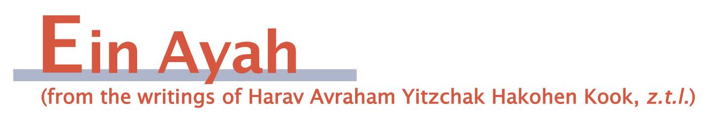

The Spiritual Message of Mayim Acharonim
(condensed from Ein Ayah, Berachot 6:44)

Gemara: Rav Chiya bar Ashi said in the name of Rav: He who washes his hands first at the end [of the meal] is the appropriate one to make the beracha (lead bentching). Rav and Rav Chiya were sitting in front of Rabbi [Yehuda Hanasi] in a meal. Rabbi said to Rav: “Get up, and wash your hands.” [Rav Chiya] saw that [Rav] was trembling and said to him: “… he was telling you to prepare to lead bentching.”

Ein Ayah: The washing of mayim acharonim (at meal’s end) comes to alert one who wants to elevate himself in shleimut (completeness) that he should distance himself from the unavoidable animalistic imprint that involvement in physical enjoyment makes. Until he separates himself from the influence of the eating he is unfit to make the beracha, which requires one’s spirit to rise up to the appropriate lofty sanctity that behooves one who blesses Hashem. One who feels the tension of the animalistic influence and is first to take the proper steps to counter it (mayim acharonim) is the most appropriate one.
Therefore, the halacha was set to illustrate the connection between mayim acharonim and becoming elevated by the beracha to the love of Hashem. Rabbi instructed Rav to wash rather than to tell him explicitly to bentch in order to hint that only the unavoidable materialistic imprint that is found in every person, who is materialistic, prevented Rav from being fit for the beracha.
Rav trembled because he feared that Rabbi wanted him to remove an extra level of the materialistic imprint that mayim acharonim hints at. However, Rav Chiya assured him that Rabbi was referring to only the minimum level that exists in every corporal being who receives physical enjoyment, for which no one is to be blamed.
When one takes the steps to overcome the negative physical influence, he can appreciate how food is very fit to bless upon, for it need not cause one a spiritual loss but is all good and a favor for us. It is physical desire that is the direct cause of lacking in several areas. When he enjoys, washes his hands, and removes the ingrained problem, he will be able to receive the proper benefit from the food. For when man is sanctified, his materialistic inclinations become important utensils for obtaining great success, and for this they are deserving of a beracha.

The Proper Level of Asthetics
(condensed from Ein Ayah, Berachot 6:52)

Gemara: A talmid chacham should not go out with patched up shoes. Is that so? Didn’t Rabbi Chiya bar Abba go out [that way]? Mar Zutra the son of Rav Nachman said: The problem is with a patch on top of a patch.

Ein Ayah: It is proper that a complete person not be to drawn to feelings of beauty to the point that he is enslaved by them and unable to bear something that lacks charm and external beauty. If that happens, then the aesthetic sense, which was given to him to enhance his life, broaden his mind, and bring joy to his spirit, will turn into a source of depression, for when his sense of aesthetics is not reached, he will be troubled and disappointed.
On the other hand, one should not betray the tendency toward beauty to the point of erasing this important feeling. After all aesthetics can elevate the spirit and prepare man to know truth and true honor, as it can play significant role in knowing Hashem and enjoying His goodness and grandeur.
Rav Chiya bar Abba reached the following balance. He went out with patched shoes to show an element of not caring and certainly not being enslaved by the pleasant desire for beauty. Yet, he did not go out with patches on patches, which would have openly robbed aesthetics of a place as something of use and value. The two opposing messages he sent led to a path of moderation.

Responsa B'mareh Habazak, Volumes I, II, III, IV, V and now VII:
Answers to questions from Diaspora rabbis. The questions give expression to the unique situation that Jewish communities around the world are presently undergoing. The answers deal with a developing modern world in the way of “deracheha, darchei noam”. The books deal with the four sections of the Shulchan Aruch, while aiming to also take into consideration the “fifth section”
which makes the Torah a “Torah of life”.
Special Price: 15$ for one book or
7 volumes of Responsa Bemareh Habazak for $90 (does not including shipping).
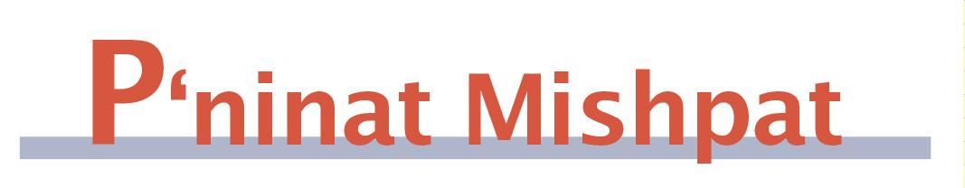

A Sales Contract Signed by Only One Spouse
(condensed from Shurat Hadin, vol. VII, pp. 125-134)

Case: The plaintiff sold an apartment to the defendant years ago, but only he, and not his wife (a joint owner), signed the contract. After problems transferring a mortgage, he wants to invalidate the sale with the claim that his wife did not authorize it.

Ruling: There are many sources that promote the thesis that when one who is close to the person whose authority is needed for a monetary matter acts to accomplish the matter, we can assume that he does it with their permission and authority. [We will present just a few.]
The Rama (Choshen Mishpat 96:6) cites an opinion that since women are involved in family finances, we treat a wife as an agent of her husband (even in cases where he has sole authority). Although the Rama rules not to extract money based on this opinion, the Shach (ad loc.:9) says that all agree regarding cases where one can assume she acts with her husband’s agreement that her transactions are binding. He continues that this is certainly the case when the husband knows what transpired and does not protest. The important guideline that the Shach provides is that it all depends upon the way the dayan sees it.
In this case, the dayanim view the matter as one that the wife agreed to. The sale took place and was known to her well before the argument of her alleged opposition arose. There was a previous court case, which focused on pl’s dissatisfaction with the mortgage situation, and the wife’s opposition to the sale was not mentioned. One cannot claim that the mortgage difficulties created a mekach ta’ut (a transaction based on mistaken information) because the facts were available, and if the sellers did not research the matter, they cannot void the sale.
Here there is an additional reason to validate the sale and that is the fact that the husband is a full partner in the property. The Shulchan Aruch (CM 122:9) says that one partner can represent the others in court proceedings without explicit authorization, if there is reason to believe that he represents the interests of all of them.
Even if we do not view the initial transaction as having the wife’s acquiescence, the fact that she was quiet afterwards confirms the matter (see Netivot Hamishpat 81:5). Furthermore, even if the contract was done in an invalid manner, subsequently while living in the apartment, the buyer did actions that serve as a kinyan chazaka. Since by that time, the wife certainly was aware and did not protest, the buyer’s actions should create the kinyan if still needed. Even if no one intended these actions to serve as a kinyan, still, according to many opinions, the fact that the kinyan was done within the context of a sale, where both the seller and the buyer are interested in the sale, the kinyan works according to many opinions (see K’tzot Hachoshen 275:4).

Mishpetei Shaul
Unpublished rulings by our mentor, Maran Hagaon HaRav Shaul Yisraeli zt”l
in his capacity as dayan at the Israeli Supreme Rabbinical Court.
The book includes halachic discourse with some of our generation’s greatest poskim.
The special price in honor of the new publication is $20.

Do you want to sign your contract according to Halacha?
The Rabbinical Court, “ Eretz Hemdah - Gazit ”
Tel: (077) 215-8-215 beitdin@eretzhemdah.org Fax: (02) 537-9626

Eretz Hemdah - Gazit serves the public in the matter of dispute resolution
according to the Halacha in a manner that is accepted by the law of the land.
While drawing up a contract, one can include a provision which assigns
the court jurisdiction to serve as an agreed upon arbitrator.

Eretz Hemdah is the premier institution for training young rabbis to take the Israeli Rabbinate's rigorous Yadin Yadin examinations. Eretz Hemdah, with its distinctive blend of Religious Zionist philosophy and scholarship combined with community service, ensures that its graduates emerge with the finest training,the noblest motivations resulting in an exceptionally strong connection to
Jewish communities worldwide.

