
Chukat 25, 5771

“We are Ready to Go Up” – Proper Willingness to Sacrifice
Harav Yosef Carmel

Twice in the book of Bamidbar, there is mention of a battle involving a place called Chorma. The first is in Parashat Shelach, in the aftermath of the sin of the spies (Bamidbar 14: 40-45). Hashem told the people they could enter the Land, but a group of enthusiastic people known as the ma’apilim attempted to go despite Moshe’s warnings. There, we are told that the Canaanites and the Amalekites smote them until Chorma. The second tells of a counterattack of the Israelites against the Canaanites that ended successfully at Chorma (ibid. 21: 1-3). The early commentaries dispute whether these are referring to different elements of the same battle, which took place in the second year in the desert, or whether they are referring to events that were separated by almost 40 years. Let us take the approach of Unkelus, Ibn Ezra, and others, who see the accounts relating to the same event, and see what we can learn from it.
The account of the ma’apilim contains several elements that we would like to take note of. The people woke up early in the morning, saying “henenu” (we are ready) to go up “to the place that Hashem spoke of.” Moshe warned them not to because “Hashem will not be in your midst.”
Many of these elements are present in an even more famous section of the Torah, that recounting akeidat Yitzchak (the binding of Isaac). Avraham said he was ready and woke up early in the morning to go to the place that Hashem had appointed. Yitzchak, too, said he was ready. In both cases, people were ready to give or risk their lives for what they believed was desired by Hashem. The great difference was that Avraham went to the mountain on which it was said that “Hashem will be seen.” In contrast the ma’apilim went in a situation where Hashem was not in their midst.
Why was Hashem’s presence found in one place and missing in the other? Avraham and Yitzchak nullified their personal interests in order to fulfill that which Hashem had commanded them to do, at the cost of dear life. However, the ma’apilim did what they wanted, albeit to get to the Land that Hashem had wanted to give to Bnei Yisrael, but not by following His commandments. That ended in Chorma, in destruction (which is what the word means). However, in the part of the story that is accounted in our parasha, the people first received permission to fight and swore to dedicate their victory and its spoils to Hashem. In that case, the destruction was done by them in retaliation against the enemy.
Let us hope that the young and brave amongst us, who are ready to sacrifice their lives, will do so in a manner of being ready to listen to Hashem’s instructions.


This edition of  Hemdat Yamim  is dedicated  to the memory of  R' Meir  ben Yechezkel  Shraga Brachfeld o.b.m | This edition of  Hemdat Yamim  is dedicated to the memory of  Rabbi Shlomo Marzel o.b.m,  who passed away  on Iyar 10th, 5771 | Hemdat Yamim  is endowed by  Les & Ethel Sutker  of Chicago, Illinois  in loving memory of  Max and Mary Sutker  and  Louis and Lillian Klein, z”l

Eretz Hemdah
Deans: Harav Yosef Carmel, Harav Moshe Ehrenreich
2 Bruriya St. corner of Rav Chiya St. POB 8178 Jerusalem 91080
Tel: 972-2-5371485 Fax: 972-2-5379626
Email: info@eretzhemdah.org web-site: www.eretzhemdah.org
Donations are tax deductable according to section 46 of the Israeli tax code
American Friends of Eretz Hemdah Institutions
c/o Olympian, 8 South Michigan Ave., Ste. 605, Chicago, IL 60603, USA
Our Taxpayer ID #: 36-4265359

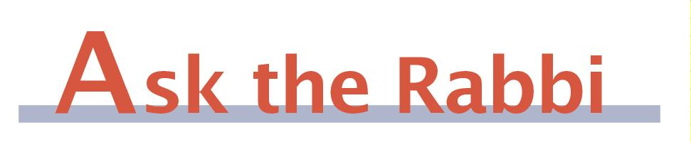
by Rav Daniel Mann

We last publicized this question seven years ago. However, the problem recurs enough to justify periodic repetition. If the reader has not had his tefillin shel rosh adjusted since then, he is probably wearing them incorrectly now.

Question: Where is the exact place to put the tefillin shel rosh? It appears that many men put them too low in front, and no one says anything!

Answer: There is nothing new under the sun. Rav Kook wrote a pamphlet called “Chevesh P’er” to strengthen the fulfillment of the mitzva of tefillin. His main complaint was that men wear the tefillin shel rosh too low (forward) on their heads and urged leaders to rectify the matter.
The gemara (Menachot 37a) learns (as opposed to the Tzedukim) that the Torah, although instructing to place the tefillin “bein einecha (between your eyes),” refers to the part of the head that can be shaved, not the forehead. Thus, the forward-most part of the tefillin may go no lower than where the roots of the hairline exit the scalp (Shulchan Aruch, Orach Chayim 27:9). If that front part does not sit directly on the head but is suspended (which is usually a sign they are too low), one draws an imaginary, perpendicular line to where it would touch.
There is a machloket among Rishonim whether the back part of the tefillin can be placed anywhere on the top of the head or only on the front half. The gemara (op. cit.) talks about putting tefillin on, or up to and including, the place of a baby’s soft spot (see Beit Yosef, OC 27 and Biur Halacha to 27:9). The most stringent opinion is that the tefillin must fit in the first 4 finger-widths (or slightly more) of the head, starting from the hairline (see Kaf Hachayim, OC 27:41). This is based on the gemara that there is room on the head to place two pairs of tefillin (Eruvin 95b), assuming a minimum of two finger-widths for tefillin (see Mishna Berura 32:189). Poskim agree that it is more crucial that the tefillin not be even slightly too low than that they not extend too far back (Chevesh P’er, 2; Biur Halacha, ibid.).
Why do so many men put their tefillin too low or too close for comfort? When large tefillin are fastened (by the part which is furthest back) so that they feel secure on the head (which is usually when they are relatively forward), they are likely to extend beyond the end of the hairline. (While it is easier to make mehudar tefillin that are big, when they are too big, it increases the problems of improper placement.) What usually happens is that people are fitted when they get new tefillin or retzuot, expecting that they are set for life. But the retzuot stretch as they are used, and the tefillin extend ever further forward. Few people know how to adjust the knot to compensate, and many don’t know that this is periodically necessary. Even someone who knows the halachic element, but is bald or has a receding hairline, is likely to assume that all is well and that the tefillin look low because of a receding hairline. Although we do follow the original hairline, many exaggerate how low it was and have no way of checking other than memory or comparing themselves to the younger generation. (Old pictures don’t always show the roots.).
It is important to correct people whose tefillin slip down and certainly those whose retzuot are so stretched out that they may not have fulfilled the mitzva in years and make a beracha l’vatala daily (see Rav Kook’s appeal). However, one must be very careful how he corrects others (see Rashi, Vayikra 19:17). It is best if the rabbi periodically urges men to ask him to check and/or adjust. If this is not done, an individual may have little choice but to gently approach those who need help. For some, it pays to leave an anonymous note. (The sensitivity issue is usually more acute for older people, who are more likely to resent being approached by someone much younger.) Asking, “Do you want your kesher adjusted?” is preferable to, “Your tefillin are on wrong”). It takes little dexterity and training to do the adjusting, and it does not require undoing the knot.

“Living the Halachic Process”
We proudly announce the publication of our second book in English.
“Living the Halachic Process volume II” a selection of answers to questions from our Ask the Rabbi project. A companion CD containing source sheets for the questions is also available.
In honor of the book’s debut, we offer it at the special rate of $25
Special offer: buy both volumes for the price of $40.

Contact us at info@eretzhemdah.org
Have a question?..... e-mail us at
info@eretzhemdah.org

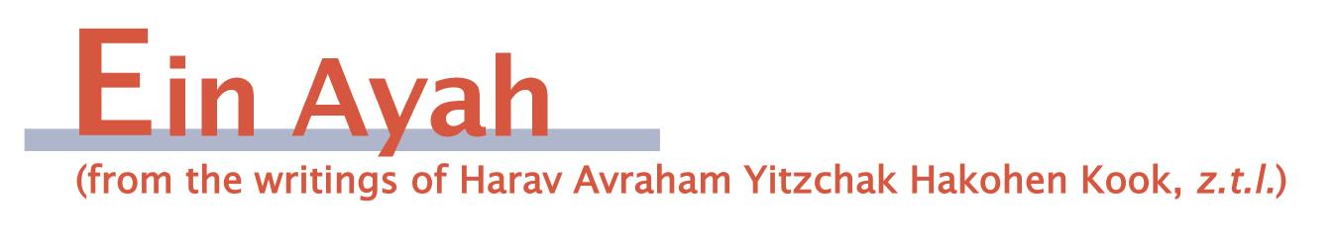

The Balance Between Different Elements of Torah Learning
(condensed from Ein Ayah, Berachot 7:4)

Gemara: How do we know that the metargem (he who translates the Torah reading into Aramaic, according to the old practice) should not raise his voice above that of the koreh (he who reads)? It is as it says: “Moshe would speak, and Hashem would answer him with a voice,” i.e., according to Moshe’s voice (Shemot 19:19) … If the metargem cannot raise his voice, the koreh should lower his while reading.

Ein Ayah: The end of the gemara indicates that the koreh and metargem should speak at the same volume. However, the greater emphasis is on the rule that the metargem should not be louder than the koreh. What is the significance behind this balance?
The Torah’s impacts upon Israel in two ways. One is through the Torah’s special quality and sanctity, whose light raises the soul until the person is closer to Hashem’s sanctity and light. This occurs even if one does not understand and is just exposed to the Torah. The second benefit from Torah comes from knowing its content, which teaches the community and the individual the straight path to take in life. This leads one to a good life and the world to come. The koreh and metargem correspond to these two elements. The koreh invokes the sanctity of the Torah on those who listen even without understanding. The translation get across the information the Torah has to relay.
If one shifts the weight to either element, it affects the balance between the elements and can cause pitfalls; true success comes when they are balanced equally. If one stresses Torah knowledge, he will be like those who study Torah without first making a beracha, a phenomenon that was responsible for “the Land being lost” (Nedarim 81a). In this way, he somewhat equates the Torah with other forms of wisdom, which can extinguish the special light of Torah and blind people’s eyes from seeing the aura of its sanctity. On the other hand, if one focuses too much on the Torah’s innate sanctity, he weakens his resolve to serve Hashem with great understanding and depth, both in the Torah’s halachic and philosophical elements. This is damaging not only because one lacks the knowledge, but because the impact of the Torah’s sanctity correlates to the effort put in to knowing the Torah.
The metargem, who represents Torah knowledge, must not be louder than the koreh because this might give the impression that knowledge is foremost, as it is in other realms of human knowledge. On the other hand the koreh should not be louder and thereby indicate that the emotional side of appreciating the Torah should come at the expense of expertise in its study.
There is a further, surprising insight, which the gemara hints at when it says that if the metargem cannot read with a robust voice, the koreh should lower his voice. At times, there is a difficult religious atmosphere in which people have trouble realizing the Torah’s sanctity because they are distant from true knowledge of Hashem. Then, we are instructed to forgo the ideal of stressing the spiritual element of the Torah. Rather one must then employ the rabbinic dictates of “if only they left me but kept My Torah,” “a person should always learn [even] for not the right reason, as from learning for not the right reason one will come to learn for the right reason,“ and “the light that is in it will return him to the right path” (Yerushalmi, Chagiga 1:7). Eventually he will see the Torah’s sanctity. In the meantime, the approach toward teaching the group is to lower the religious demands before coming to the Torah so that people will get at least a basic knowledge of the Torah’s content and know what to do.
The idea of sanctity and knowledge going hand in hand emanates from Sinai, where, the gemara says, Hashem’s voice (the sanctity) and Moshe’s voice (the information) were as one. The more effort one puts into the knowledge the more he will feel the sanctity. This is a message to be learned by all generations.

Responsa B'mareh Habazak, Volumes I, II, III, IV, V and now VII:
Answers to questions from Diaspora rabbis. The questions give expression to the unique situation that Jewish communities around the world are presently undergoing. The answers deal with a developing modern world in the way of “deracheha, darchei noam”. The books deal with the four sections of the Shulchan Aruch, while aiming to also take into consideration the “fifth section”
which makes the Torah a “Torah of life”.
Special Price: 15$ for one book or
7 volumes of Responsa Bemareh Habazak for $90 (does not including shipping).
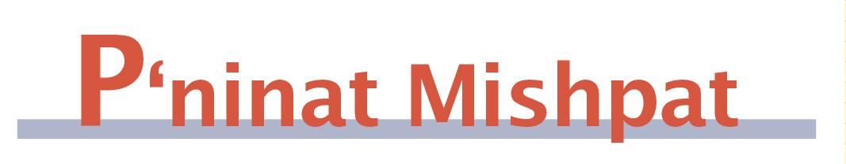

Divorce With Problems About the Ketuba

(condensed from Shurat Hadin, vol. IV, pp. 101-104)

Case: The husband (=pl) has been demanding divorce for 12 years. Beit din ruled that the wife (=def) is obligated to receive a get. Pl is poor and cannot pay the ketuba, but def is living in an apartment owned by his parents, and they are willing to let her continue staying there for free as instructed by beit din.

Ruling: The minimum value of a ketuba (200 zuz) is, according to the Shulchan Aruch (Even Haezer 66:6) 37.5 drahm or 120 grams of silver. The Rama rules that the currency of the ketuba is based on Torah-level currency, which means this is multiplied by 8, making the sum 960 grams. A standard Ashkenzai ketuba adds 200 zekukim for property the wife brings into the marriage and an addition to the basic ketuba. That sum comes to 57,000 grams, according to the Chazon Ish, and 2,784 grams, according to the Nachalat Shiva. The more accepted ruling is like the latter (Piskei Din Rabbaniim XI). In the couple’s ketuba, the ancient silver currency was also translated into Israeli currency, at 170,000 liras. However, since the ketuba does not link the lira sum to any price index, that is now worth less than a basic ketuba, due to inflation.
There are different opinions regarding whether raising the amount due to change in the currency is a violation of ribbit. The Taz (end of Even Haezer 66) says that a ketuba is not a loan, and therefore it can go up if the currency is increased, except regarding the element of the dowry. The Maharit (II, EH 2) says that although the gemara says that after a currency change one uses the lesser currency, that is only in regard to the usability of the currency, but if the weight of coins changes, one follows the original currency to which one obligated himself. The Chatam Sofer (EH 126) says that this is a case where the authority of the king/government determines how to translate the old currency into present-day use. In the final analysis, because of the different opinions, def is entitled only to the weight in silver of the 200 zuz plus the calculation of zekukim according to the Nachalat Shiva.
However, pl is unable to pay even that amount in the immediate future, and the question is whether he can give a get under those circumstances. The Beit Yosef (EH 117) cites the Rosh that the woman is to receive the get, after which he will have an obligation upon him which will be paid as feasible. On the other hand, he cites (in EH 119) the Rashba as saying that he is not allowed to give a get if he is not able to pay the ketuba. The Beit Yosef and Rama (EH 119:6) side with the Rosh. The Chelkat Mechokek (119:5) says that the Rosh may only have spoken in a case where the wife has an obligation to receive the get, but that in a case that the get is optional, he has be able to pay the ketuba. The Oneg Yom Tov adds that the husband is allowed to give the get without the ketuba only when it is possible to force the husband to pay.
In our case, since def is obligated to receive a get, beit din has the ability to enforce obligations, and there is a reasonable solution for def (use of pl’s parents’ apartment) in lieu of ketuba payment, there is no need to delay the get any further.
Mishpetei Shaul
Unpublished rulings by our mentor, Maran Hagaon HaRav Shaul Yisraeli zt”l
in his capacity as dayan at the Israeli Supreme Rabbinical Court.
The book includes halachic discourse with some of our generation’s greatest poskim.
The special price in honor of the new publication is $20.

Do you want to sign your contract according to Halacha?
The Rabbinical Court, “ Eretz Hemdah - Gazit ”
Tel: (077) 215-8-215 beitdin@eretzhemdah.org Fax: (02) 537-9626

Eretz Hemdah - Gazit serves the public in the matter of dispute resolution
according to the Halacha in a manner that is accepted by the law of the land.
While drawing up a contract, one can include a provision which assigns
the court jurisdiction to serve as an agreed upon arbitrator.

Eretz Hemdah is the premier institution for training young rabbis to take the Israeli Rabbinate's rigorous Yadin Yadin examinations. Eretz Hemdah, with its distinctive blend of Religious Zionist philosophy and scholarship combined with community service, ensures that its graduates emerge with the finest training,the noblest motivations resulting in an exceptionally strong connection to
Jewish communities worldwide.

