
Yom Kippur 10 Tishrei 5772

Our Uniqueness on the Special Day
Harav Daniel Mann

“Days are created and You have one among them” (Tehillim 139:16). The midrash (Eliayhu Rabba 1) says that this one day is referring either to Shabbat among the days of the week, or Yom Kippur among the days of the year. Yom Kippur is a unique day, a day in which Hashem provides a special kedusha and closeness to Him, and a day in which we are expected to respond with the type of behavior that brings us to a level where we can approach Hashem, kaveyachol.
Several statements of Chazal connect our behavior and appearance on Yom Kippur to that of the angels serving Hashem in the Heavens on a daily basis. Pirkei D’Rabbi Eliezer (45) tells that Hashem grants Samael power over Israel on Yom Kippur if he can find sin in us, but that he finds us like angels: we do not eat or drink, we are without shoes, we stand a lot, and we have peace between us. Indeed, the five inuyim, in which we refrain from basic human luxuries and even necessities, make us resemble angels, whom we do not attempt to imitate during the rest of the year (except, to some extent, during Shemoneh Esrei and Kedusha).
Rav Yaakov Moshe Charlop (Mei Marom, vol. VII, 43) sees us as resembling Adam before his sin and explains the significance of not eating along those lines. It is possible for people to be “above time.” Eliyahu did this during the 40 days that he walked with the strength received from that which he ate before leaving (Melachim I, 19:8). Adam also was on this level before his sin, as the food that he ate could have satiated him continuously. The natural processes that prevent this are related to our enslavement to the natural passage of time.
By refraining from eating on Yom Kippur, says Rav Charlop, we signify that the food that we eat before Yom Kippur (which is a special mitzva) can last us as we reach toward the high level of the first human before his sin. That food is thus reminiscent of the fruit of the Garden of Eden. Indeed, Adam himself was on a level that was similar to an angel and in some ways above their level (see Bereishit Rabba 8, which tells that originally, the angels were confused by Adam’s greatness and wanted to say Kedusha to him).
It is important to view the mitzvot of the day not only as an obligation and not only as a condition for getting through the day with a maximum of atonement and a minimum of sin. Rather, it is an opportunity to experience being on the type of level where we can feel our own potential for greatness, and hopefully want to adopt much more of it throughout the year than we did in the past. True, we remain fully human, and those who medically need to eat must do so and not get carried away with the comparison to angels, Adam, or Eliyahu. However, we should all focus on those special powers that, perhaps we identify in uniquely holy individuals, but fail to see in ourselves.
Hemdat Yamim is dedicated  to the memory of  the beloved friend  of Eretz Hemdah  Doris (Doba) Moinester  whose Yahrtzeit is 23rd of Elul | This edition of Hemdat Yamim  is dedicated to the memory of  Mr. Jay Pomrenze's father  Col. Seymour “Sholom”  Pomrenze z"l  who passed away  on Av 26, 5771 | This edition of  Hemdat Yamim  is dedicated  to the memory of  R' Meir  ben Yechezkel  Shraga Brachfeld o.b.m | This edition of  Hemdat Yamim  is dedicated to the memory of  Rabbi Shlomo Merzel o.b.m,  who passed away  on Iyar 10, 5771 | Hemdat Yamim  is endowed by  Les & Ethel Sutker  of Chicago, Illinois  in loving memory of  Max and Mary Sutker  and  Louis and Lillian Klein, z”l

Eretz Hemdah
Deans: Harav Yosef Carmel, Harav Moshe Ehrenreich
2 Bruriya St. corner of Rav Chiya St. POB 8178 Jerusalem 91080
Tel: 972-2-5371485 Fax: 972-2-5379626
Email: info@eretzhemdah.org web-site: www.eretzhemdah.org

Donations are tax deductable according to section 46 of the Israeli tax code
American Friends of Eretz Hemdah Institutions
c/o Olympian, 8 South Michigan Ave., Ste. 605, Chicago, IL 60603, USA
Our Taxpayer ID #: 36-4265359

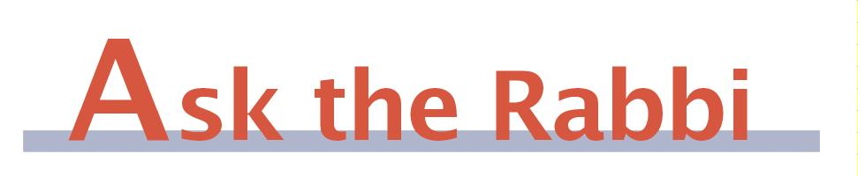
by Rav Daniel Mann

Question: I understand that this year, with Yom Kippur falling out on Shabbat, we will not be saying Avinu Malkeinu, except at Ne’ila. What makes Avinu Malkeinu fitting, among all the tefillot of Yom Kippur, to be eliminated, and why is Ne’ila an exception?

Answer: First, we imagine you are Ashkenazi, as most Sephardic communities do recite Avinu Malkeinu on Yom Kippur that falls out on Shabbat, although many leave out the passages that mention sinning (see Yechaveh Da’at I, 54 and Mikraei Kodesh (Harari), Yom Kippur 5:12). Many Sephardim even say Avinu Malkeinu on Rosh Hashana that falls out on Shabbat and on Shabbat Shuva (ibid.).
Indeed, almost all Ashkenazim and some Sephardim omit Avinu Malkeinu on Shabbat even on Yom Kippur. The reason is that one is not allowed to make requests on Shabbat (Rama, Orach Chayim 584:1 and Mishna Berura ad loc. 4). It is true that we do recite passages that contain special requests (e.g., Zachreinu l’chayim …) on Shabbat, and the justification is that since they are written in the plural, it is considered the needs of the community, which is permitted (see Tosafot, Berachot 34a). However, the fact that Avinu Malkeinu originated as a special prayer for fast days (Ta’anit 25b) is part of the reason that it is treated as a particularly plaintive prayer that is inappropriate for Shabbat. This is despite the fact that it is recited in plural and is a regular part of our davening throughout Aseret Y’mei Teshuva (Orchot Chayim, Rosh Hashana 2). The Aruch Hashulchan (OC 619:8) has a different take on it. He says that intrinsically one is allowed to make any type of request on Yom Kippur, as the Yud Gimmel Middot and many piyutim are no less strong than Avinu Malkeinu. Rather, the Rabbis chose to omit Avinu Malkeinu as a reminder that elements of Shabbat exist despite being largely overshadowed by the outpouring of the feeling of trepidation associated with Yom Kippur.
Avinu Malkeinu is considered an important prayer, and we do not easily give up on its use. One practical indication of this is the bending of a rule. Usually we do not say Avinu Malkeinu on Erev Yom Kippur. However, the Rama (OC 604:2) says that when Yom Kippur falls out on Shabbat, causing us to limit Avinu Malkeinu’s recitation on Yom Kippur, we do recite it in Shacharit of Erev Yom Kippur. Some compare our relinquishing of our right to use this “spiritual tool” in honor of Shabbat to that of not blowing shofar when Rosh Hashana is on Shabbat, where our regard for Shabbat itself “sweetens our judgment” (see Divrei Yehuda (Scheinfeld), p. 201). There are voices raised to allow Avinu Malkeinu specifically on Yom Kippur when it falls out on Shabbat because of the urgency of our having our last chance to achieve atonement before the end of Hashem’s judgment (Ran, Rosh Hashana 9a of the Rif’s pages).
Regarding why we say Avinu Malkeinu specifically at Ne’ila, there are at least three explanations. The Levush (OC 623:5) says that by that time Shabbat is out, so there is no longer a problem. The Magen Avraham (623:3) says that even if a shul gets up to Avinu Malkeinu before nightfall, they still recite it because now it is indeed the last chance (applying the aforementioned Ran to this case of the very last opportunity). Finally the Mateh Ephrayim (623, K’tzeh Hamateh 8) cites the Maharil who says that we want to take the opportunity to say Avinu Malkeinu in the only tefilla where we insert “chotmeinu” (seal us) in place of “kotveinu” (inscribe us).
The Rashbetz (III, 176), one of the major sources on the matter, stresses that there are various minhagim on these matters, and one should not change the local practice based on what seems to be a preferred alternative minhag. With the help of whatever words we will end up saying, we should be “sealed” this Yom Kippur for a good year, full with lives of health, happiness and true meaning, on both a national and an individual level.

“Living the Halachic Process”
We proudly announce the publication of our second book in English.
“Living the Halachic Process volume II” a selection of answers to questions from our Ask the Rabbi project. A companion CD containing source sheets for the questions is also available.
In honor of the book’s debut, we offer it at the special rate of $25
Special offer: buy both volumes for the price of $40.

Contact us at info@eretzhemdah.org
Have a question?..... E-mail us at
info@eretzhemdah.org

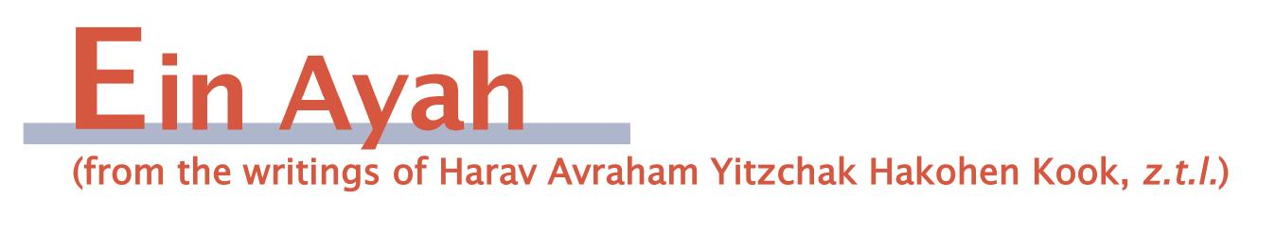

Thank for What?
(condensed from Ein Ayah, Berachot 7: 39-40)

Gemara: From a person’s berachot it is clear whether he is a Torah scholar or not. In what way? Rebbi says: If he says [in zimun], “… and in His goodness we have lived,” he is a scholar. If he says, “… and from amongst His goodness we have lived,” he is ignorant. Abayei asked Rav Dimi: Doesn’t the pasuk say: “and from amongst Your blessings may You bless your servant’s house forever” (Shmuel II, 7:29)? A request is different. But regarding requests, as well, the pasuk says: “Widen your mouth and I will fill it” (Tehillim 81:11)!? This is talking about [requests for] matters of Torah.

Ein Ayah: All that exists in the world is Hashem’s goodness, as the Rambam writes (Moreh Nevuchim 1:54) regarding the pasuk, “I will pass all of My goodness before your face” (Shemot 33:19). The proper way to look at the world is that all of its physicality and spirituality is connected, like a person who has various limbs.
Therefore, one who recognizes deeply Hashem’s greatness should not say that we “live from amongst His goodness,” which implies that he is thanking Hashem only for the part of Hashem’s goodness that affects him. This is because the flow of life is connected to all of existence, which is, in turn, all of His goodness. That is why a scholar says “in His goodness,” implying all of it.
In contrast, even one who is not on the level of a scholar and naturally views matters on a simpler level should go beyond his normal feelings and contemplate the grandeur of the more complete outlook on the world. While it is hard for him to express himself like the scholar, he should not limit himself by talking explicitly about only that which affects him personally. One who so limits himself is considered ignorant. If he cannot express matters like a scholar, he should have the scholar bentch and upon hearing his mode of proper expression, respond in kind. The ignorant person will not be able to even contemplate something beyond him and will stress the goodness that comes to him individually.
Rav Dimi says that there is a distinction in this regard between expressing gratitude and making requests. Gratitude comes from a lofty element of one’s soul, which is awakened to the propriety of recognizing the good one has received. He should pursue this feeling in regard to Hashem’s goodness in the broadest possible manner. Requests, in contrast, emanate from that which a person identifies as being missing within himself. Focusing on one’s own needs does, to a moderate degree, entrenches in himself a self-love, which is not actually bad, as this is needed for a person to be able to contribute to the collective. After all, if a person lacks basic self-love, he will not have the foundation upon which to build the higher levels of justice and correct behavior.
Therefore, in regard to requests, one should allow the focus on the personal to come out. When it comes to giving thanks, he should go beyond the personal and use his intellect to focus on that which is good in the entire world. This approach is a natural progression from a proper life of Torah and mitzvot, which is the secret of life for everything in the world. This is hinted in the pasuk, “the goings on (halichot) of the world are His” (Chabakuk 3:6). The Rabbis expound: “Do not read it as halichot but as halachot (the laws of the Torah). That is why David asked, “and from amongst Your blessings may You bless your servant’s house forever.”
This, though, is in regard to requests of physical needs. When one elevates himself to request spiritual improvement, it is proper to focus on the true, broader perspective. When the related pasuk mentions widening one’s mouth to ask, it is not merely in regard to a quantitatively large request, but a qualitatively more significant request, which relates to the collective more than to the individual.

Responsa B'mareh Habazak, Volumes I, II, III, IV, V, VI and now VII:
Answers to questions from Diaspora rabbis. The questions give expression to the unique situation that Jewish communities around the world are presently undergoing. The answers deal with a developing modern world in the way of “deracheha, darchei noam”. The books deal with the four sections of the Shulchan Aruch, while aiming to also take into consideration the “fifth section”
which makes the Torah a “Torah of life”.
Special Price: $15 for one book or
$90 for 7 volumes of Responsa Bemareh Habazak (does not including shipping)

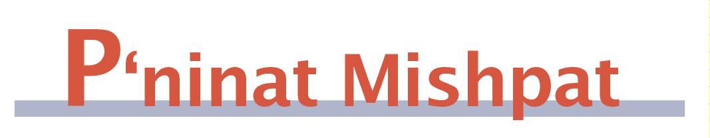

Freezing of Assets as a Result of a Claim for Spousal Reconciliation

(condensed from Shurat Hadin, vol. VIII, pp. 551-554)

[This ruling is one of many that highlight the tensions that exist between the secular courts and the religious courts due to their complicated overlapping jurisdiction.]

Case: The couple in question has appeared before beit din for years, originally with the wife demanding divorce and the husband demanding reconciliation. More recently they signed a divorce agreement, which granted the wife a lot of property, and it received the status of a court ruling when the secular regional court signed it. Now they are back in beit din, once again disagreeing on whether they will or will not get divorced, with the husband claiming that the agreement was done in order to prevent creditors from seizing his assets. Beit din ordered a temporary freeze on the assets until completion of the deliberations. The regional court disallowed the freeze that related to the agreement that they approved.

Ruling: The secular regional court has no right to try to undo beit din’s order, as the two courts have equal jurisdiction, and any discrepancy between the two must be resolved by the Supreme Court. The appeal that is before the Supreme Court is surprising, considering that the lawyers for both sides agreed to the temporary freeze.
In general, the secular court’s authority to approve divorce agreements is based on The Law of Monetary Relations Between Spouses, which applies to beit din as well. A divorce agreement, by its nature, is linked to the eventuality of divorce. If the couple no longer agrees on divorce, then it is not enforceable. Since the religious court has exclusive jurisdiction regarding whether there is an obligation of divorce and there has been no decision that there needs to be divorce, the secular court may not give a ruling to carry out the divorce agreement.
There are two elements to the monetary relations between spouses. One is of partners in property. The other is of monetary arrangements that allow for the proper functioning of the family unit. Some of the monetary arrangements, including elements of the ketuba, are matters that the Rabbis did not allow to be tampered with, even by agreement of the sides. Therefore, as part of its jurisdiction over matters related to the viability of the family unit, beit din must be given jurisdiction to rule unless and until there is a decision for divorce. They certainly have the right and obligation to render a temporary restraining order when the basic relationship is directly affected.

Mishpetei Shaul
Unpublished rulings by our mentor, Maran Hagaon HaRav Shaul Yisraeli zt”l
in his capacity as dayan at the Israeli Supreme Rabbinical Court.
The book includes halachic discourse with some of our generation’s greatest poskim.
The special price in honor of the new publication is $20.
Do you want to sign your contract according to Halacha?
The Rabbinical Court, “ Eretz Hemdah - Gazit ”
Tel: (077) 215-8-215 beitdin@eretzhemdah.org Fax: (02) 537-9626

Eretz Hemdah - Gazit serves the public in the matter of dispute resolution
according to the Halacha in a manner that is accepted by the law of the land.
While drawing up a contract, one can include a provision which assigns
the court jurisdiction to serve as an agreed upon arbitrator.

Eretz Hemdah is the premier institution for training young rabbis to take the Israeli Rabbinate's rigorous Yadin Yadin examinations. Eretz Hemdah, with its distinctive blend of Religious Zionist philosophy and scholarship combined with community service, ensures that its graduates emerge with the finest training, the noblest motivations resulting in an exceptionally strong connection to
Jewish communities worldwide.

