

Shoftim 2 Elul 5769

A United Arm and Head
Harav Moshe Ehrenreich

As Bnei Yisrael draw near to entering Eretz Yisrael, our parasha focuses on the laws of war. After the kohen exhorts the men not to be afraid and exempts certain people at life’s crossroads, those who are “afraid and weak of heart” are sent away (Devarim 20:1-8). R. Akiva says that these people were literally scared despite the encouragement. R. Yossi says it refers to those who sinned in matters from the Torah. R. Yossi Hagelili says it is talking about those who sinned in rabbinic matters, e.g., those who spoke between putting on the tefillin of the arm and of the head.
What is unique about this ostensibly mild infraction? The Beit Yosef (OC 25) cites the Razah, saying that even though each of the tefillin is a separate mitzva, it is proper that they make one havaya (roughly, entity). Why is this? The main idea of tefillin of the arm is to remind the individual of his personal, practical obligations to Hashem. Therefore, they are opposite the heart and preferably covered up, as they are personal and warrant modesty. In contrast, the tefillin of the head are worn proudly on top of the head, where they show the nations of the world that Hashem’s Name is upon us so that they will fear us (based on Berachot 6a; see Tosafot ad loc.).
Rav Ch. D. Halevi explained the matter of one havaya as follows. National completeness requires two elements: 1) individuals must fulfill their personal obligations; 2) there must be recognition of our unique national standing. The halacha is that when one is prevented from donning one of the tefillin, he still is to fulfill the one he is capable of. Similarly, on a philosophical level, when our nation is in exile, unable to reach our potential national glory, we are still required to be exacting in our personal religious obligations. Also, if the nation succeeds in raising the national banner while lacking in the realm of individual religious observance, there is still value in the national status. However, it is important to realize that either one without the other comprises a sickly state to be avoided to the extent possible. That is why one who takes a break between one of the tefillin and the other is so bad. He seems to deny the importance of the connection between the arm and the head, i.e., the individual observance and the national status.
We also understand the story of “Elisha Ba’al Hakenafayim,” the tzaddik who defied the Roman decree that whoever donned tefillin would have his head punctured and was saved by a miracle. The decree was focused on the head, not the arm, because the Roman’s were interested in lowering our national stature.
When serving in the army, one must be very aware that his mission does not allow him to separate between the tefillin of the arm and of the head. Such service is not only national, it is also religious. It is not only religious, it is national as well. One who is not able to put the two together has cause to be “afraid of the sins in his hand” and may be sent away as unfit to serve.
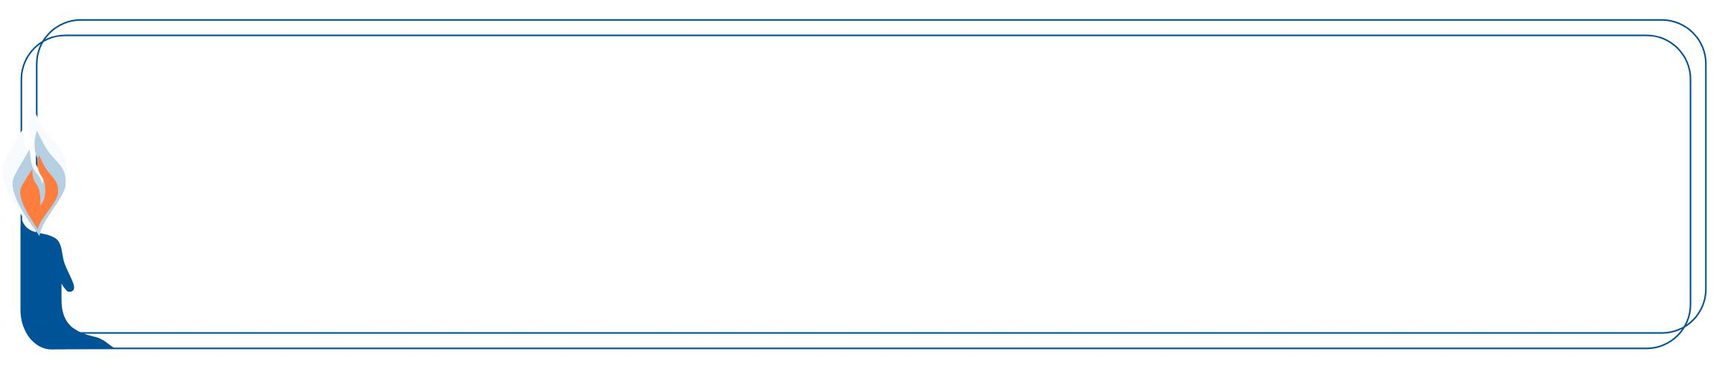

We at Eretz Hemdah express our condolences to Rabbi Yosef Carmel, the Head of the Kollel
On the passing of his mother, Malkah Toibeh, o.b.m.

This edition of Hemdat Yamim  is dedicated to the memory of  R ' Meir ben  Yechezkel Shraga Brachfeld  o.b.m | Hemdat Yamim of this week  is dedicated in memory of  Yitzchak Eizik Usdan ben Yehuda Leib a"h,  whose Yahrtzeit is the 29th of Av | Hemdat Yamim is endowed by  Les & Ethel Sutker  of Chicago, Illinois  in loving memory of  Max and Mary Sutker  and  Louis and Lillian Klein, z”l.

Eretz Hemdah is the premier institution for training young rabbis to take the Israeli Rabbinate's rigorous Yadin Yadin examinations. Eretz Hemdah, with its distinctive blend of Religious Zionist philosophy
and scholarship combined with community service, ensures that its graduates emerge with the finest
training, the noblest motivations resulting in an exceptionally strong connection to
Jewish communities worldwide.

ERETZ HEMDAH
Deans: Harav Yosef Carmel, Harav Moshe Ehrenreich
5 Ha-Mem Gimmel St. P.O.B 36236 Jerusalem 91360

Tel: 972-2-5371485 Fax: 972-2-5379626

Email: info@eretzhemdah.org web-site: www.eretzhemdah.org



Question: My son is buying a house and I said that, please G-d, I would give him a present of $10,000 (= $10K) to help, but he now needs another $20K to complete the transaction. He is unable to get commercial financing, but I am. I understand that it is forbidden for me to take a $20K loan in my name and have him pay the bank the interest or reimburse me. (Correct?). May I, instead, reduce the $10K present to compensate for the losses on the $20K loan, considering my pledge of the present was just an oral statement?

Answer: First, let us praise you for the halachic sophistication of the question. Indeed, there is an apparent prohibition for your son to pay the interest on a loan that you will take and transfer the money to him (Shulchan Aruch, Yoreh Deah 168:1). This is because actually two loans will exist. The bank will give you $20K. Then you will be lending your son $20K, and he will return to you $20K plus interest, which is forbidden whether he pays it to you directly or to the recipient of your choice (e.g., the bank). (There is a possible avenue of leniency if matters can be arranged so that it is not viewed halachically as his paying you interest but reimbursing the expenses you incur to getting the money for him. We have an unpublished tentative leniency along those lines, but the conditions are complicated enough that we prefer providing simpler solutions.)
First, we will deal with your excellent suggestion. Not only is it forbidden for the borrower to give money beyond the principal to the lender but it is forbidden for the lender to receive from him any extra service or benefit of even moderate value. A borrower certainly must not be mochel (relinquish rights to) money due to him from the lender in appreciation for the loan (see Bava Metzia 64b). The question is how to view the pledged $10K present.
If one pledges to give a present to someone without doing an act of kinyan that concretizes the pledge, he cannot be compelled to honor his pledge. However, if it is a small present, he is considered to be mechusar amana (lacking in trustworthiness) if he does not do so (Bava Metzia 49a). Since authorities may take some steps to pressure him to fulfill this moral obligation (see Pitchei Choshen, Kinyanim 1:1), if the projected recipient waives the payment, this is considered doing a favor of monetary value. However, $10K is not a small present. (The determination of big and small is likely subjective (B’tzel Hachochma V, 158) and should depend not only on the giver’s wealth but also on the level of his relationship with the recipient. However, your question implies that a $10K present to your son is something that you do not take lightly.) If you have no obligation to pay, then even if you would have been embarrassed to back out, your son’s forgoing of part of the present to receive the loan is probably not considered ribbit (implication of the Chatam Sofer, YD 135 regarding a lender to the community who was exempted from their rotation of taking in guests). If your son is considered poor, there is a problem because a promise of even a large present to an ani is binding as a vow (Shulchan Aruch, YD 258:12).
There are two ways to allow you to receive more than $20K back from your son (allowing you to leave the present). 1) Make a heter iska, the standard solution for framing what might have been a loan into a (partial) investment. Your son will be required to give you profits (according to your written forecast, equal to what the bank is charging) from the investment of $20K on your behalf unless he can bring corroboration that these profits were not achieved. 2) (Somewhat advantageous when the use of the money is known) Write a document whereby the $20K makes you a part owner of the house. Your son’s payments will be a gradual buying out of your partnership plus rent corresponding to your part (Igrot Moshe, YD II 62). For more details about such documents, see The Laws of Ribbit (Reisman), especialy. pp. 259-260, or get back to us.

“Living the Halachic Process” - We proudly announce the publication of our first book in English. “Living the Halachic Process” a selection of answers to questions from our Ask the Rabbi project. A companion CD containing source sheets for the questions is also available.
In honor of the book’s debut we offer it at the special rate of $20 (instead of $25).
Contact us at info@eretzhemdah.org

Have a question?..... e-mail us at
info@eretzhemdah.org

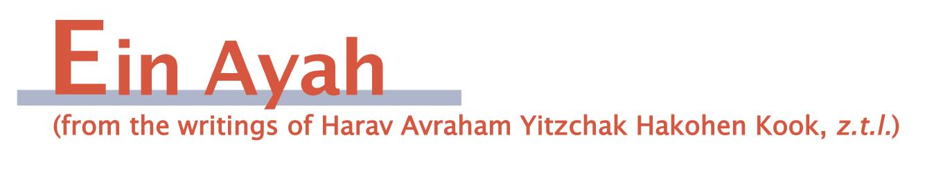
The Purpose of Dreams
(based on Ein Ayah, Berachot 2:24)

Gemara: R. Zeira said: Whoever slept seven days without a dream is called bad, as the pasuk says … R. Yochanan said: Whoever satiates himself with words of Torah and then sleeps will not be told bad tidings.

Ein Ayah: The natural phenomenon of dreams was not created without a purpose. The gemara explains that the purpose of frightening dreams is to soften the tough nature of the inclination of a person’s heart. Therefore, if a significant amount of time passes and nothing comes to cause a person’s hard nature to be softened, his tough characteristics will acquire strength and he will be called bad.
However, Rabbi Yochanan qualifies this by saying that this is true only regarding a person whose activities all follow the nature of his soul. One who puts his heart on the path of dedication to Hashem’s Torah does not need natural events to soften his personal characteristics, as the Torah will teach him and straighten his path. That is why one who satiates himself with words of Torah will not be told bad tidings [in dreams] because he is always close to the path of good. Wisdom, which weakens his physical powers, will make his characteristics proper.
It is also possible that when a person sleeps, his physical side gains prominence, and he will become increasingly drawn to it. Therefore, it is important to dream, as it makes him use at least a partially intellectual capacity to imagine things in his mind, thus preventing him from become overly enveloped in physicality during his sleep. However, when he rests his body from the hard work of Torah study, he does not become overtaken by physicality, rather he experiences a means of reaching spiritual completeness. Therefore, it is best that he not be disturbed and his sleep should be pleasant to him.

Unwarranted Embarrassment and Warranted Pain
(based on Ein Ayah, Berachot 2:26)

Gemara: After he would finish his prayers, Rabbi Yochanan would say: “It should be Your will … that You peek (tatzitz) at our embarrassment and gaze (tabit) at our bad situation…”

Ein Ayah: Peeking is considered looking in a difficult manner. In other words one has to make an effort to see something that was not fit to be discerned unless one concentrates specially. Realize that embarrassment is an emotion of the soul that applies even to lofty matters. If the person who embarrasses is respected and the matter about which one is embarrassed is rightly embarrassing, then the feeling is proper. However when a lowly person embarrasses a fine person for having done something good, then one should not really feel ashamed.
In our lowly state, those who disgrace us are those of an unrefined heart and a lacking spirit. For what are they shaming us if not for doing something good, namely, for observing the covenant that we have with Hashem! We should properly not feel any shame. Nevertheless, since we have weakness of the spirit and improperly feel shame, we still ask Hashem to look at us according to our actual feelings, despite the fact that it stems from a lacking within us. That is why we ask Hashem to be meitzitz (peek), not according to the value of Hashem’s completeness but according to our weak spirit.
We ask Hashem to gaze at our lowness in our bad situation. A bad situation clearly causes hard feelings and does not stem from the lowliness of the spirit. Rather it is a fundamental reaction of the body to react to pressure and pain even though physical pain does not have intrinsic value. In any case, since the bad situation warrants hard feelings, we can ask Hashem to be mabit, to look directly to see something that deserves to be seen.

Responsa B'mareh Habazak, Volumes I, II, III, IV, V and VI:
Answers to questions from Diaspora rabbis. The questions give expression to the unique situation that Jewish communities around the world are presently undergoing. The answers deal with a developing modern world in the way of “deracheha, darchei noam”. The books deal with the four sections of the Shulchan Aruch, while aiming to also take into consideration the “fifth section” which makes the Torah a “Torah of life”. (Shipping according to the destination)Special Price: 6 volumes of Responsa Bemareh Habazak - $75 (instead of $90)

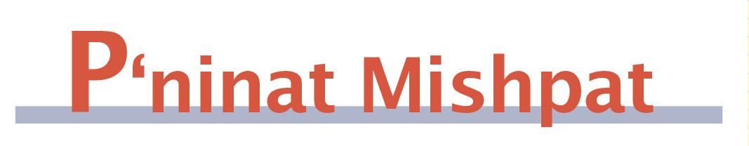

(Zeh Neheneh V’zeh Lo Chasser) This One Benefits and This One Does Not Lose
(based on Eit Ladun, Halacha Psuka, vol. 58, by Rav Akiva Kahane)

Sometimes, one has to pay for services that he did not agree to pay for. We will view the topic of zeh neheneh v’zeh lo chasser (=znvzlch) in relation to the following case. A company designed the facade of someone’s house and then used a picture of it in their advertisement, for which the homeowner demands compensation.
The gemara (Bava Kama 20-21) discusses one who lived in his friend’s home without permission, thereby saving rent, where the homeowner did not lose because it was not slated for rental. The Shulchan Aruch (Choshen Mishpat 363:6) rules that until the owner tells the squatter to leave, the latter is exempt from rent because in a case of znvzlch, one is not obligated to pay.
The Pnei Yehoshua explains that we entertain the possibility of payment because the benefit one receives from another innately obligates the recipient. Yet, znvzlch is exempt because we do not allow the giver to accept payment, which would be along the lines of the “attribute of Sodom,” who refused to do favors. The Chidushei Harim says that while benefit can obligate, in the case of znvzlch the benefit does not come directly from the provider to the recipient. For example we do not obligate someone to pay for seeing something enjoyable in his neighbor’s yard. One does not have ownership over every type of use of his object. A major factor that determines over what he has ownership is when another’s use causes the owner a loss. The difference between the explanations is when there is a loss, so Sodom does not apply, yet the benefit is not sufficiently related to the owner.
What is considered a loss to the owner? Tannaim argue about a case where a renter lends a cow to a borrower, by whom it dies without fault. Rabbanan say that since renters are exempt and borrowers are obligated, the borrower pays the renter. However, we accept R. Yossi’s opinion: “how can one do commerce with another’s cow?” The Chidushei Harim asks why the owner can complain about the renter’s receiving payment, as it seems to be like a case of znvzlch. He answers that an animal owner can object to the renter’s giving the cow to another who might keep the animal for himself, making the whole situation one of slight loss. Similarly, the homeowner in our question can say that public exposure of his home could increase the chance of robbery.
Rav Shimon Shkop answers the above question by saying that a monetary obligation that emanates from one’s property, i.e., the compensation for the cow’s death, naturally belongs to the owner. While this applies to R. Yossi’s case, in the case of the advertisement, no money emanates from the house. Rather, there is a benefit that tangentially relates to the house, for which there is not a natural right of the homeowner. Therefore, the legal validity of the owner’s demand would depend on whether we accept the Chidushei Harim’s or Rav Shimon Shkop’s explanation.

Mishpetei Shaul
Unpublished rulings by our mentor, Maran Hagaon HaRav Shaul Yisraeli zt”l in his capacity as dayan at the Israeli Supreme Rabbinical Court.
The book includes halachic discourse with some of our generation’s greatest poskim. The special price in honor of the new publication is $20.



Av 26 – Elul 2, Bava Metzia 113-119

“Stand Outside” – Collecting Debt from the Borrower
Rav Ofer Livnat

This week in the Daf Hayomi, the Gemara (113-116) deals with the laws of taking collateral and collecting debts from a borrower. In the Torah, there are a number of Mitzvot pertaining to this issue. These Mitzvot come to protect the dignity of one who borrowed money and is having difficulty repaying the loan. One of the prohibitions the Torah states is that the lender is not allowed to enter the house of the borrower in order to take collateral. The Torah states: "… you should not go into his house to take his pledge. You should stand outside, and the man to whom you lend should bring out the pledge to you" (Devarim 24, 10-11). The Gemara (113a) rules that, not only is the lender prohibited from entering the borrower's house, but even the Beit Din may not send its representative to enter the borrower's home. This prohibition has been manipulated by some people who want to avoid paying their debts, by hiding their wealth inside their homes. The Rishonim deal with the issue of how the Beit Din should act when it suspects that someone is hiding money in his home in order to avoid repaying his debts.
According to Rabbeinu Tam (Sefer Hayashar Chidushim 602), the prohibition of entering the house is only when one is coming to take collateral to ensure the loan, but when coming to collect the debt, the representative of Beit Din is allowed to enter the borrower's home. However, many of the Rishonim did not accept this distinction of Rabbeinu Tam and therefore dealt with the issue in other ways.
The Sefer Haterumot (sha'ar 1 section 3) writes that, since Beit Din is allowed to work outside the law if it is necessary to maintain law and order, if Beit Din sees a wicked person who is avoiding paying his debts, the Beit Din can temporarily override the prohibition of entering the borrower's home. The Rambam (Malveh Veloveh 2, 4) writes that the Beit Din needs to find ways to force such a person to pay, such as expelling him from the community. However, it appears from the Rambam that even in such a case, his home may not be entered, since the Torah specifically stated that this is prohibited.
The Beit Yosef (97, 28 in the Bedek Habayit) writes that, since according to Rabbeinu Tam, it is permitted to enter the house of the borrower when coming to collect the debt, and according to other Rishonim this may be done outside the law when Beit Din sees a need for it, therefore, it may be done when Beit Din suspects that one has assets and is hiding them in his home. He rules this way in the Shulchan Aruch (97, 15) as well.

*********************************************

Do you want to sign your contract according to Halacha?
The Rabbinical Court, “Mishpat Vehalacha BeYisrael”
Tel: (077) 215-8-215 beitdin@eretzhemdah.org Fax: (02) 537-9626

Serves the public in the matter of dispute resolution according to the Halacha
in a manner that is accepted by the law of the land.
While drawing up a contract, one can include a provision which assigns
the court jurisdiction to serve as an agreed upon arbitrator.

