 | 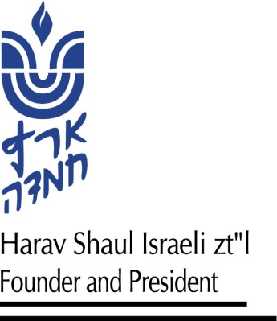
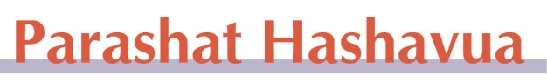
Vaetchanan, 15 Av 5781
Who Heard Ten?
Harav Yosef Carmel

Parashat Vaetchanan, which we are reading, as usual, on Shabbat Nachamu, returns us to the Ten Commandments, which were given in a “once in world history” event – the revelation of Hashem to Bnei Yisrael at Mt. Sinai. We also read the parasha of Shema, which we recite twice a day, thereby accepting Hashem’s sovereignty over us. One thing that unites these special Torah portions is the matter of shemi’ah (hearing).
There is a machloket what exactly we/our forefathers heard at Sinai. The simple reading of our parasha indicates that we heard all ten of the dibrot (or devarim, as the Torah calls them) from Hashem directly: “… the sound of devarim you (pl.) are hearing … and He told you His covenant, which He commanded you to do, the ten devarim” (Devarim 4:12-13). “Face to face Hashem spoke with you at the mountain from the fire … [The Ten Commandments] … these devarim Hashem spoke with your whole assemblage …” (ibid. 5: 4-19).
The opinion of “the Rabbis” in Shir Hashirim Rabba (1:2) indeed says that the nation heard all the dibrot directly from Hashem. Mechilta D’Rabbi Yishmael (Yitro 4) also says that Hashem said all of the Ten Commandments in one burst of speech and then specified each commandment individually.
On the other hand, there is another opinion in Shir Hashirim Rabba (ibid.) that the nation as a whole heard only two dibrot. Rabbi Yehoshua learns from “He shall kiss me from the kisses of His mouth” that we only heard some of the dibrot, specifically the first two – “I am Hashem …” and “You will not have other gods …” Others learn it from gematria. “Moshe commanded us Torah,” has a numerical value of 611, as the other two of the 613 mitzvot we did not hear originally from Moshe but directly from Hashem. The gemara (Makkot 23b-24a) advances this approach based on Moshe’s statement: “I am going to stand between Hashem and you at that time to tell you the word of Hashem” (Devarim 5:5).
The Rambam (Moreh Nevuchim II:33) suggests a third possibility. At Sinai the people did not hear Hashem’s words; only Moshe did. What the people experienced was the powerful, wondrous sounds and sights of Hashem speaking to Moshe, who shared the specific content with them.
After “begging pardon” from the great participants in this machloket, we humbly suggest an approach that can “make peace” between the above. According to tradition, all the Jewish people throughout the generations stood at Sinai and accepted the Torah together. This includes especially righteous people, those who were apparently wicked, and the many who fell between the extremes. Perhaps the fully righteous heard all the commandments from Hashem directly. The wicked heard only the sound of Hashem speaking to Moshe. The average people heard two commandments from Hashem and the rest through Moshe.
Specifically, in these difficult times, we should remember and stress that we are one nation. All of us, the different parts of the nation over the generations, were at Sinai. Let us decrease hatred and polarization. We should remember that “anochi” (i.e., one’s ego) stands between Hashem and us. Let us subdue that which divides us. With the help of an improved approach to holding ourselves personally accountable, let us turn the sad days into joyous ones.


Hemdat Yamim is dedicated to the memory of:

Eretz Hemdah's beloved friends and Members of Eretz Hemdah's Amutah
 |  |  | Mr. Moshe Wasserzug z"l  Tishrei 20, 5781 |  |  | Mr. Shmuel & Esther Shemesh z"l Sivan 17 / Av 20 |  |  | Rav Reuven Aberman z”l  Tishrei 9, 5776 |  |  |  | Rav Shlomo Merzel z”l  Iyar 10, 5771
R' Meir ben Yechezkel Shraga Brachfeld z"l  & Mrs. Sara Brachfeld z"l  Tevet 16, 5780 |  |  |  |  | Mrs. Sara Wengrowsky bat R’ Moshe Zev a”h  10 Tamuz, 5774 |  | R' Eliyahu Carmel z"l  Rav Carmel's father  Iyar 8, 5776 |  |  | R' Yaakov ben  Abraham & Aisha and Chana bat Yaish & Simcha Sebbag z"l |  | Hemdat Yamim is endowed by  Les z"l & Ethel Sutker of Chicago, Illinois, in loving memory of  Max and Mary Sutker  & Louis and Lillian Klein z”l
 |  | R' Benzion Grossman z"l Tamuz 23, 5777 |  |  |  | R' Abraham & Gitta Klein z"l Iyar 18 / Av 4 |  | Rav Yisrael Rozen z"l  Cheshvan 13, 5778 |  |  | Rav Asher & Susan Wasserteil z"l  Kislev 9 / Elul 5780
Rav Moshe Zvi (Milton) Polin z"l Tammuz 19, 5778
R' Yitzchak Zev Tarshansky z"l Adar 28, 5781
R' Yitzchak Eizik ben Yehuda Leib Usdan z"l, Av 29
Gital Gila Bat Eliyahu Michael a”h on the occasion of her yahrzeit, Av 21st

Those who fell in wars for our homeland. May Hashem avenge their blood!

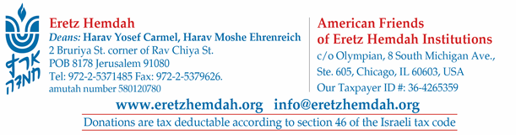


by Rav Daniel Mann

Homeopathic Remedies on Shabbat

Question: Is it permitted to ingest homeopathic remedies on Shabbat?

Answer: We start with our approach to “alternative medicine,” which includes homeopathy (some use the terms interchangeably). Alternative medicine is subject to disagreement, from the grass roots to health agencies. As in most realms, extreme opinions are likely incorrect. Some treatments under the umbrella of alternative medicine are helpful; others are quackery and serve as a placebo at best (although sometimes placebos are useful). The efficacy or even safety of some medicines and treatments (homeopathic or conventional) is uncertain or varies from person to person. We are not in the position to take a stand on which treatments fall into which category. For the purpose of this general question, we will treat the remedy in question as one to which the user legitimately attributes medicinal efficacy and about which the objective observer is rightly skeptical.
It is prohibited to perform medical procedures, including ingesting medicine, to cure or calm a non-severe malady (Shulchan Aruch, Orach Chayim 328:37). The rationale is concern that one who is involved in such activity might violate Shabbat in the process, i.e., by grinding herbs (Shabbat 53b). The cases in which the prohibition does not apply fall into two broad categories: 1. When the need justifies certain halachic compromises (see Shulchan Aruch ibid. 17). Nafal l’mishkav (needing to lie down) is a classic description of such need (Rama, OC 328:37). 2. When the procedure is not considered dealing with illness or is otherwise dissimilar from cases in which there is a concern of chillul Shabbat.
In category #1, since normal Halacha is compromised, the steps taken must be truly warranted. Therefore, the Magen Avraham (328:1) allows chillul Shabbat to save a life only if the medicine is known (not theorized) to be effective (based on the Rama, Yoreh Deah 155:3 regarding eating non-kosher medicine). Therefore, even if someone is sick or suffering enough to allow medicine, he should not be allowed to use a homeopathic medicine if that is not scientifically accepted (as Halacha grants medical experts authority to determine the medical situation in a given case (Shulchan Aruch, OC 328:10)).
However, our case is different from the Magen Avraham’s in a couple of ways. On the one hand, there the need is to save a life, which brought the Pri Megadim (ad loc.) to ask why one may not try even an otherwise forbidden treatment of unknown efficacy if it is the only chance at survival. On the other hand, the violations to be waived are of a Torah level, whereas here we only need to waive a Rabbinic violation, so might even an unproven remedy not suffice? Actually, the Pri Megadim says that is specifically by a Rabbinic prohibition and not life-threatening illness that we need a proven medicine.
Might one argue that if the medicine is legitimate, it should be permitted based on need, and if it is not, it should be permitted because it is a non-medicine? Halachic logic dictates that it is not the status of medicine that causes the prohibition but that a sick person is searching for a cure that is close enough to cases of possible chillul Shabbat. In that way, homeopathic medicine is no better than conventional medicine.
Therefore, we believe that most homeopathic (see Shevet Halevi V:55) and other unproven treatments are forbidden on Shabbat (we will not get into defining what activities might be outside the realm of medicine and therefore permitted – see Mishna Berura 306:36). If one wants to use them for nagging situations that are not nafal l’mishkav, standard medicines are also problematic. Usually little is lost if one takes doses right before and after Shabbat. Presumably, one can use the leniency of inserting the medicine into a food or drink so that it is indiscernible before Shabbat and then eating on Shabbat (see Shulchan Aruch, ibid. 21; Orchot Shabbat 20:131). In unique cases, one who perceives great need and no alternatives should contact his rabbi and/or doctor.

Do not hesitate to ask any question about Jewish life, Jewish tradition or Jewish law.

SEND NOW!
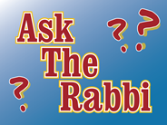

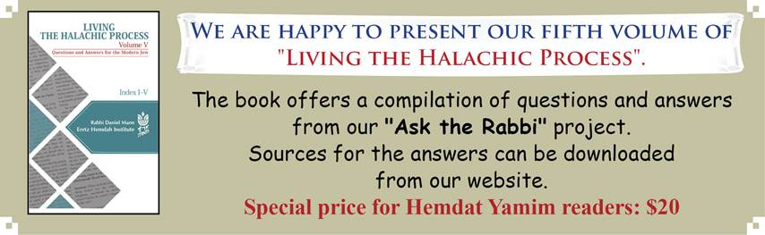

Yerushalayim First and Foremost – Letter #39 – part II

Date and Place 3 Marcheshvan 5667 (1906), Yafo

Recipient: Rabbi Yehuda Leib Felman, an uncle of Rav Kook

Body: [Last week we saw Rav Kook’s disappointment over tensions among kollelim and the beginning of his thesis that Yerushalayim’s historic/spiritual centrality should find expression even in regard to practical matters of financial support.]
[Based on what we have seen,] the status of Yerushalayim is greater than that of all other places, as does the mitzva to build it precede and surpass that of the other holy cities. A proof for this is the gemara (Berachot 6b) concerning participation in a wedding: “If you bring joy to the groom, it is as if you built one of the ruins of Yerushalayim.” It did not talk about building the ruins of anywhere in Eretz Yisrael, even though this is implied by the pasuk cited (“… as I will return the captives of the Land” – Yirmiyahu 33:11). It must be because building the ruins of Yerushalayim is a greater mitzva than doing so for other cities, and so they mentioned the more prominent one.
One should not think that the early righteous people could have settled in Yerushalayim and preferred another city in Eretz Yisrael. We see these days, as well, that all of the Torah scholars and righteous people desire to settle in Yerushalayim specifically. Many travel to visit it and pray on special days at the Western Wall (may it be built quickly in our days) with sanctity and incredible inspiration. Rather, the yoke of exile has been very heavy in Yerushalayim because of the traditional hatred of the non-Jews.
Only now, in ikva d’meshicha (the stage preceding the coming of Mashiach) do we see good omens – Hashem is treating us in a manner of salvation and mercy. Thank G-d, some of our Jewish brethren are distinguished in the eyes of the officials, in the Holy Land in general and Yerushalayim specifically. Thank G-d, things are now safe, and there is no fear.
One should not ask about the greatest righteous people – why did some choose to live in other holy cities, even when they could have lived in Yerushalayim? Certainly every location in Eretz Yisrael has its own individual root and element of sanctity, as is discussed at length in Chessed L’Avraham.
Even on a simple level, every place has its own special holy appeal. For example, my location of Yafo is special in that it is on the border specified in the Torah (“the border of the sea” – Bamidbar 34:6), and it is the place the prophet Yonah came to, which certainly embedded in it special spiritual characteristics that have remained over the generations. It is also the place where the rafts made of cedar wood were brought to land to be used in building the Beit Hamikdash (see Divrei Hayamim II, 2:15). According to the Yerushalmi, a miracle happened to Nikanor in its port.
Therefore, although Yerushalayim is very beloved, it has the most all-encompassing sanctity, and there is a precedence to live there, still whoever felt in the root of his unique soul a connection to a certain city’s special individual sanctity would decide to live there.
The Land was divided among tribes, and therefore there were prophets from different tribes and locations. Although most were in Yerushalayim, which is why it was called the “valley of visions” (Yeshayahu 22:1) and when a prophet’s city is not mentioned he can be assumed to be from there (Petichta 24), a minority lived in other places. These are specific matters, but generally there is certainly a greater mitzva to live in Yerushalayim than anywhere else, despite the beloved nature of every place. To this day, elders who have lived in Eretz Yisrael and try every day to travel in new paths within it because of their great love for the Land, still try their best to live in Yerushalayim. It is just that many are forced by their situation or their finances to live elsewhere.

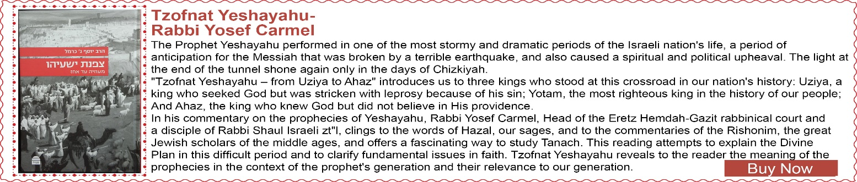



A Loan or a Partnership? – part I

(based on ruling 79099 of the Eretz Hemdah-Gazit Rabbinical Courts)

Case: The defendant (=def) bought an apartment for approximately 600,000 NIS but did not have enough money to pay. The plaintiff (=pl), def’s brother, gave him around half of the price. Def has been paying pl 1,000 NIS a month for the last 18 years and an additional 220,000 NIS (according to pl) or 270,000 NIS (according to def). Pl claims he bought half of “his brother’s apartment” and that the monthly payment was for rent for his half. Now that the apartment is worth 1.8 million NIS, pl wants def to buy his part at 680,000 NIS (half its value minus the amount paid; the monthly rent payments are not included). Def counters that the money was a loan, and the monthly payment was interest. Not being religious, he did not know that interest is forbidden, and so he now demands that pl return the interest, as Halacha requires. Pl presented a handwritten “document,” which contains several provisions that support pl’s claims, including that def must pay half of normal rent and that they have equal ownership in the apartment. Pl claims that def wrote the document, and a brother of the two corroborates that this is def’s handwriting.

Ruling: The first thing to determine is the relevance of the alleged document. The note has no signatures or date and uses only first names. It does not even refer to a specific apartment by address or description. The final clause within it is in a different handwriting, which admittedly is pl’s, which shows the lack of reliability of the note to serve as a binding document.
The brother’s testimony about the handwriting and his claim that he discussed with pl being partners in the apartment are the testimony of a relative which is of course invalid. The source pl cited about a relative’s testimony serving as a revelation of known matters does not apply here when the basic facts are in dispute. Furthermore, even if we were to accept the brother’s account, the note is not written in a manner that can be binding. Even if the witness is correct that the two brothers discussed being partners in def’s apartment, that does not mean that def agreed to the arrangement.
There is a manuscript of a recorded conversation between pl and def that refers to the existence of a document of some sort. However, it does not describe the type of document that would be legally binding. Furthermore, the note is full of discrepancies. For example, in one of the clauses, it refers to a loan of $69,000, which based on the exchange rate at that time, is slightly more than 270,000 NIS, which the sides agree was transferred. To be clear, the two sides agree that pl gave def a significant amount of money to buy the apartment and that pl was intended to receive significantly more money than he gave to def. Regarding the exact conditions, we do not have agreement or proof.
Next time we will complete analysis and see the decision.

------------------------------------------------------------------------------------------------------------

We daven for a complete and speedy refuah for:

Nir Rephael ben Rachel Bracha
Yisrael ben Rivka
Rivka Reena bat Gruna Natna
Arye Yitzchak ben Geula Miriam
Neta bat Malka
Meira bat Esther

Together with all cholei Yisrael

-----------------------------------------------------------------------------------------------------------

Comments or questions regarding articles can be sent to: info@eretzhemdah.org

Eretz Hemdah is the premier institution for training young rabbis to take the Israeli Rabbinate's rigorous Yadin Yadin examinations. Eretz Hemdah, with its distinctive blend of Religious Zionist philosophy and scholarship combined with community service, ensures that its graduates emerge with the finest training, the noblest motivations resulting in an exceptionally strong connection to
Jewish communities worldwide.

