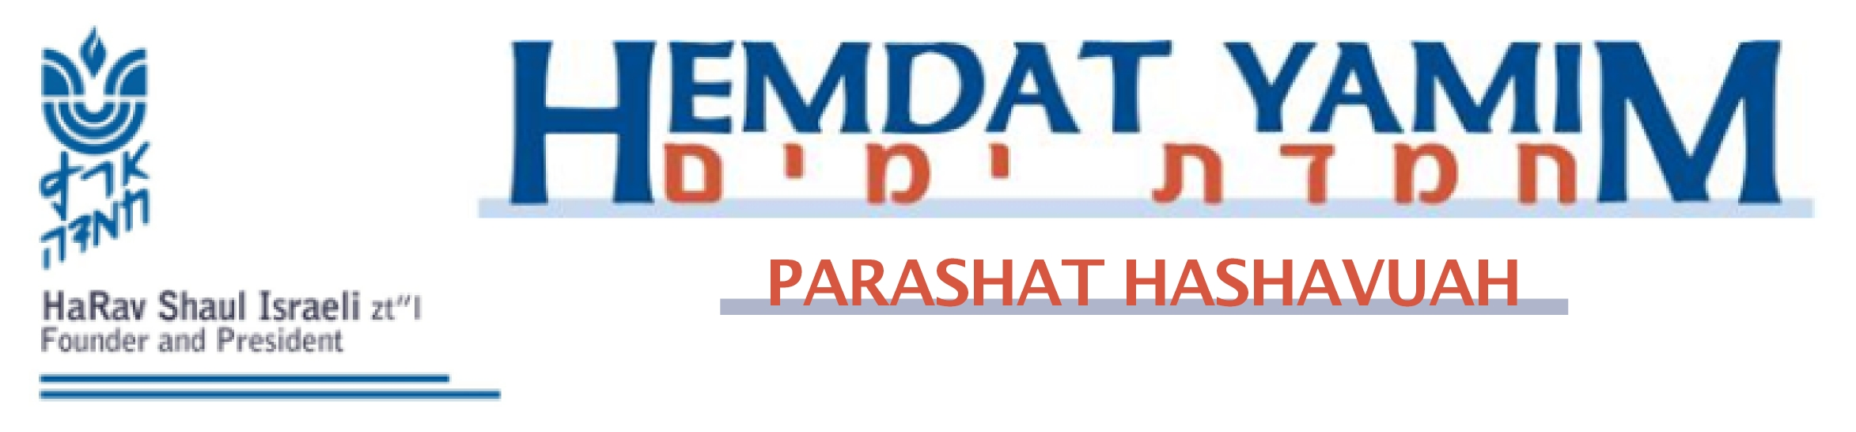

Rosh Hashana 1 Tishrei 5770

A Day of Remembrance

This Rosh Hashana, we will be without the mitzva from the Torah that is so central to the experience of the day, the blowing of the shofar. Not only do we miss the opportunity to do a mitzva, but it also makes us somewhat apprehensive going into our judgment without the protection it provides. How are we supposed to feel about missing the shofar?
The Netivot Shalom (Rosh Hashana 6) says that the sound of the shofar does actually accompany us. The mishna (Rosh Hashana 29b) says that when Rosh Hashana falls on Shabbat, the shofar is blown in the mikdash (sanctuary) but not in the medina (in the country, in general). The Beit Avraham is cited as saying that medina refers to actions that we do with our body, whereas mikdash refers to our minds. Indeed, without blowing the shofar this Shabbat, the concept of the shofar accompanies our minds.
The gemara (ibid.) says that we do not blow shofar out of concern that someone will carry it outside. The Yerushalmi attributes the lack of shofar blowing to p’sukim. One of the references to shofar blowing in the Torah calls Rosh Hashana a “day of blasts” (Bamidbar 29:1) whereas the other one refers to a “remembrance of blasts” (Vayikra 23: 24). When Rosh Hashana falls on Shabbat, we fulfill the element of remembrance. It is strange, though, that the first and more central of the discussions of Rosh Hashana should refer to the exception to the rule, when the shofar is missing. The Netivot Shalom answers that the “fulfillment” of shofar on Shabbat is actually the higher level: the remembrance of shofar is in our minds without needing the physical blowing. Usually, he explains, the shofar inspires us in the manner of yirah (fear of Heaven). Shabbat adds the element of ahava (love), which joins together with yirah to create a harmonious whole.
It is interesting that the word used to connote the involvement in shofar without the action, “zichron,” shares the root of the word for the positive commandment of our commemoration of Shabbat, “zachor” (Shemot 20:8; see Berachot 20b). What great positive actions do we do to commemorate Shabbat? We make a declaration that the day is Shabbat (which rabbinically we enhance with wine and a longer than Biblically necessary recitation) and that’s it. Perhaps this is the idea of Shabbat. Hashem rested from activities and imbued the world with a special concept – that a thought-out refraining from activity can bring as much or more to the world as creating heavens, earth, and all that reside in them. Rosh Hashana corresponds to the sixth day of creation, when everything was completed – except Shabbat. When Shabbat coincides with Rosh Hashana, we cannot ignore Shabbat, and we introduce the element of contemplation on lofty ideals and ceasing to act within the commemoration of Rosh Hashana.
May we be able to experience Rosh Hashana with the sanctity of Shabbat that entered the world as its creation was completed and thereby coronate Hashem in a most significant way.

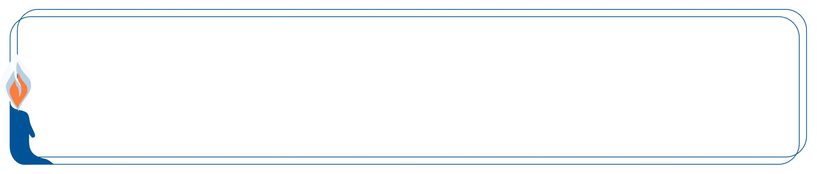

This edition of Hemdat Yamim  is dedicated to the memory of  R ' Meir ben  Yechezkel Shraga Brachfeld  o.b.m | Hemdat Yamim is dedicated  to the memory of the  Prof. Emeric Deutsch, z”l  member of Eretz Hemdah’s Amuta | Hemdat Yamim is endowed by  Les & Ethel Sutker  of Chicago, Illinois  in loving memory of  Max and Mary Sutker and  Louis and Lillian Klein, z”l

Eretz Hemdah is the premier institution for training young rabbis to take the Israeli Rabbinate's rigorous Yadin Yadin examinations. Eretz Hemdah, with its distinctive blend of Religious Zionist philosophy
and scholarship combined with community service, ensures that its graduates emerge with the finest
training, the noblest motivations resulting in an exceptionally strong connection to
Jewish communities worldwide.

ERETZ HEMDAH
Deans: Harav Yosef Carmel, Harav Moshe Ehrenreich
5 Ha-Mem Gimmel St. P.O.B 36236 Jerusalem 91360

Tel: 972-2-5371485 Fax: 972-2-5379626

Email: info@eretzhemdah.org web-site: www.eretzhemdah.org

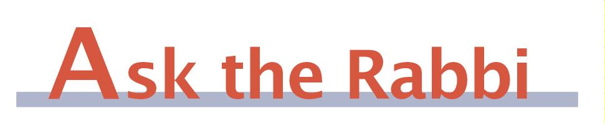

Question: After finishing blowing or hearing shofar blowing on Rosh Hashana, is the shofar muktzeh from that point on?

Answer: First we have to check if it is permitted to blow the shofar after the mitzva is completed. If it is permitted, then the shofar is a kli shemelachto l’heter (a utensil used for permitted purposes) and will be able to be moved for any reasonable purpose.
This matter is actually the subject of substantial machloket. The Rama (Orach Chayim 596:1) says that it is forbidden to blow the shofar for no specific need on Rosh Hashana after he has fulfilled the mitzva. He (in the Darchei Moshe, OC 588:2) refers to earlier sources that indicate this approach. The Tur (OC 589) cites an opinion that a man may not blow shofar on Rosh Hashana just for a woman after fulfilling the mitzva himself, since the mitzva does not apply to her and thus it is blowing without justification. We reject this opinion because we rule that there is a value for a woman, although she is exempt, to hear the shofar. Otherwise, though, it would have been forbidden. Another discussion (Tur 590) mentions that one who makes the shofar blower repeat blowing when he is not required is making him violate the rabbinic prohibition of blowing the shofar without a reason. The gemara (Rosh Hashana 33a) also talks about children blowing the shofar for practice for the future without a mitzva need, implying that an adult should not do this.
On the other hand, the Taz (596:2) argues that blowing shofar is forbidden only on Shabbat, out of concern he may carry it in the public domain, but it is permitted on Yom Tov, when carrying is permitted. He argues that the sources forbidding blowing for adults refer to Shabbat. The Ohr Zarua (II, 266) in fact explicitly permits blowing shofar all day long on Rosh Hashana that does not fall on Shabbat. In the final analysis, most poskim forbid blowing shofar without a specific purpose after fulfilling the mitzva. One may blow to fulfill the minhagim to add more blasts (100, for most) than are strictly required for the mitzva.
One of the Taz’s arguments that it is permitted to blow after finishing the mitzva is that if it were forbidden, then it would be forbidden to move the shofar due to muktzeh. In fact, the gemara (Sukka 41b) assumes that it is permitted to carry a lulav after fulfilling the mitzva, and the Rama himself says only regarding Shabbat that a shofar is muktzeh. One might then argue that since we forbid blowing shofar after fulfilling the mitzva, it should also be forbidden to move. Furthermore, the Magen Avraham (588:2) says that a special type of muktzeh applies to a shofar, namely, muktzeh l’mitzvato (an object that is set aside for a mitzva may not be used for another, non-mitzva purpose). The Machatzit Hashekel (ad loc.) implies that this muktzeh not only precludes using the shofar for another purpose but even makes it forbidden to move. However, many assume that muktzeh l’mitzvato does not prevent moving the object (Tosafot, Shabbat 45a; see Tz’lach, Shabbat 44a and Mishna Berura 588:15).
In any case, the great majority of poskim assume that even though one may not blow the shofar beyond the needs, one can move the shofar (Mishna Berura 596:3 in the name of Acharonim; Shemirat Shabbat K’hilchata (28:34)). The Mishna Berura (ibid.) explains that one cannot determine that a shofar is no longer slated to be used because it is possible that someone has not heard the shofar blowing and needs it. The Kaf Hachayim (OC 596:7) explains that since children may blow throughout the day, the shofar can be used for them.
The Shemirat Shabbat K’hilchata (20:(51)) wonders why we assume that one may move a shofar after finishing to use it but not move a brit mila knife after the mila (see the machloket between the Rama, Yoreh Deah 266:2 and Taz, ad loc.: 1). He suggests that is more common to unexpectedly find someone that is in need of shofar blowing than to find an eighth day baby who unexpectedly needs a mila.

“Living the Halachic Process” - We proudly announce the publication of our first book in English. “Living the Halachic Process” a selection of answers to questions from our Ask the Rabbi project. A companion CD containing source sheets for the questions is also available.
In honor of the book’s debut we offer it at the special rate of $20 (instead of $25).
Contact us at info@eretzhemdah.org

Have a question?..... e-mail us at
info@eretzhemdah.org

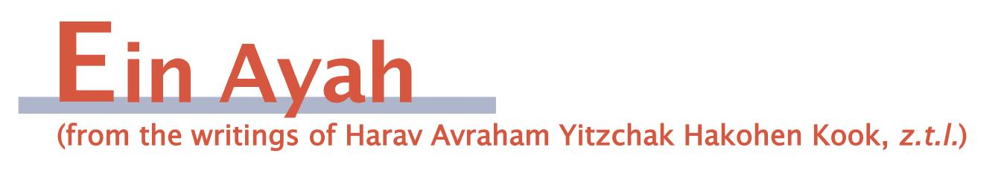
[We will go out of order to see a piece of Ein Ayah that relates to Rosh Hashana and return to a piece that shares a philosophical common denominator.]

Rosh Hashana and the Number Nine
(based on Berachot 4:44)

Gemara: These nine [berachot of the Amida] of Rosh Hashana correspond to what? Rabbi Yitzchak from Kartignin said: They correspond to the nine references to Hashem that Chana said in her prayers, as it was said: It was on Rosh Hashana that Sarah, Rachel, and Chana were remembered [with the children they prayed for].

Ein Ayah: On Rosh Hashana, all the world’s inhabitants pass before Hashem like b’nei maron, which [according to one explanation in Rosh Hashana 18a] means like a flock of sheep. This illustrates the matter of Divine Providence on an individual basis, which exists beyond the Divine Providence that relates to a species or is general Providence.
The number ten represents an entire group as a whole, as this is the lowest number that is considered a community. Therefore, the most appropriate number to represent one relating to individuals in a group as individuals is nine.
This idea applies to Chana, who requested from Hashem to fulfill her personal desire in a manner that was above the way of nature. She was not fit to give birth and requested that Hashem provide a miracle to help her as an individual, which is very much along the lines of individualistic Divine Providence. That is the reason that she mentioned Hashem’s names nine times in her prayers to show the great extent of individual Divine Providence that Hashem employs.
On Rosh Hashana, we must particularly concentrate on picturing in our mind’s eye the matter of Divine Providence for the individual. This can help us improve our individual actions and increase our evoking of mercy, each one according to his own needs. This is the way to build the success of the collective, which requires the success of its constituent parts. For this reason, the prayers of Rosh Hashana were built upon the number nine.

The Needs of the Individual and of the Collective
(based on Berachot 2:43)

Gemara: Master of the universe, it is clear and known to you that we desire to do Your desire, but who stands in the way? The yeast in the dough and the subjugation of the kingdoms. May it be Your will to subdue them from before us and after us, and we shall return to the laws of Your desire with a full heart.

Ein Ayah: A person should deal with his shleimut (completeness) in regard both to his personal matters and the shleimut of the collective by joining together with K’lal Yisrael in a manner that will bring spiritual and physical benefit to the nation by his actions. The main causes of lacking in an individual’s actions are a bad nature and its faults, which are referred to as the yeast in the dough. Regarding communal needs, which are in a low point without the strengthening of Hashem’s Torah and all good goals and attributes, it is the subjugation of the kingdoms. In all matters, we can look forward (the main part) or backward (the minor part). Really, a person is complete only when he is attached to the collective. Therefore, the front part is the communal, and the back is the individual. We ask that we should not be held back in either realm.
The matter of returning to the laws of Your desires refers to the laws of the Torah. The laws complete a person in a true way; some of them are designed to complete the collective. Therefore, only when one is prepared to improve himself, others, and the collective can he do the laws that Hashem desires with a full heart, for then he will feel the internal pleasantness of the holy Torah and mitzvot. Then Hashem’s pleasantness will be upon him to set the path of his actions.

Responsa B'mareh Habazak, Volumes I, II, III, IV, V and VI:
Answers to questions from Diaspora rabbis. The questions give expression to the unique situation that Jewish communities around the world are presently undergoing. The answers deal with a developing modern world in the way of “deracheha, darchei noam”. The books deal with the four sections of the Shulchan Aruch, while aiming to also take into consideration the “fifth section” which makes the Torah a “Torah of life”. (Shipping according to the destination)Special Price: 6 volumes of Responsa Bemareh Habazak - $75 (instead of $90)

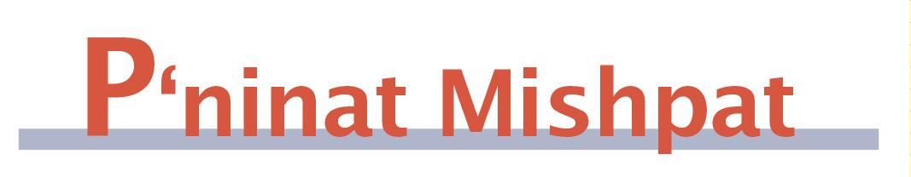

The Status of Municipal Regulations Regarding Home Expansion – part I
(based on Et Ladin, Harav Nir Vargon – Halacha Psuka, vol. 28)

The interplay between the laws of the Torah and those of the civil government can be ground for tension and disagreement due to their differences. We will concentrate on municipal regulations in regard to people’s rights to build, specifically, the law that neighbors must agree to the building expansion even when the building plan does not violate any halachic limitations.
The gemara (Bava Batra 8b) says that the people of a city can set rules for measures and price rates and enforce their regulations by means of penalty. The Mordechai (ad loc. 480) brings two opinions as to the source of this authority of the tuvei ha’ir (municipal leaders). The Maharam (accepted by the Rama, Choshen Mishpat 2:1) says that they possess the Beit Hadin Hagadol’s status that enables confiscating property when the matter is necessary for migdar milta (to fix a situation). However, Rabbeinu Tam says that migdar milta applies only to religious matters and that the tuvei ha’ir can only takes steps to enforce that which the people have already agreed upon.
There is also a machloket whether it is necessary for the regulations to be approved by an adam chashuv (important person) who is appointed to oversee the needs of the city’s people when they adversely impact on part of the population. The Rivash (399) says that this is unnecessary, but the Tashbetz (Chut Hameshulash 15), Rama (CM 231:28), and Shach (ad loc. 4) require such an approval. The Tashbetz adds that it is insufficient for the adam chashuv to be a talmid chacham; the main criterion is that he be appointed to oversee the population’s needs.
Based on the aforementioned, it is logical to accept municipal regulations as publicly approved decisions. In a time and place where there are usually not talmidei chachamim with official responsibility to oversee the public’s needs, there is logic to say that there is not a need for an adam chasuv’s approval, which is necessary only when there is an appropriate person to give it.
Some Rishonim integrate the element of the laws of the kingdom and local practice as halachic factors, beyond the element of the need to follow local regulations and the matter of dina d’malchuta. The Rashba (Shut I, 1032) says that if one opens a window to the public domain in a manner that is locally permitted, his neighbor on the other side of the street cannot make him close it. This is because the former is viewed as opening to the public domain as the king wants, which a neighbor cannot stop even if we would normally view it as an infringement on the neighbor’s privacy. The Rosh (Shut 99:6) says that in a place where the practice is to have beams extend from the houses out in the direction of the public domain, we do not say that the airspace before the house is hefker (free for all to claim).

Mishpetei Shaul
Unpublished rulings by our mentor, Maran Hagaon HaRav Shaul Yisraeli zt”l
in his capacity as dayan at the Israeli Supreme Rabbinical Court.
The book includes halachic discourse with some of our generation’s greatest poskim.
The special price in honor of the new publication is $20.

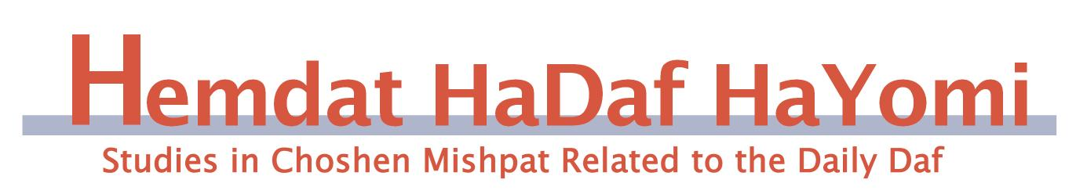

Elul 24 – Tishrei 1, Baba Batra 23-29

Chazaka on Real-Estate
Rav Ofer Livnat

This week in the Daf Hayomi, we begin to learn the third chapter of Baba Batra, which discusses when a person attains a chazaka on real-estate. A chazaka is a form of proof of ownership on an item. Regarding movable objects, the assumption is that the one holding them is the owner, even if someone else was previously known to be the owner. However, regarding real-estate, the opposite is true: the original owner is assumed to be the true owner, even if someone else is currently using the property. Therefore, if the person currently using the property claims to have bought it, he must show the shtar (purchase deed) as proof.
When does the person residing in the property attain a chazaka? The Mishna (28a) states that, after a person resides in the property for three years with no objection from the previous owner, he attains a chazaka and is no longer required to show the shtar as proof. The Gemara deals with the question of why a chazaka is attained specifically after three years. The conclusion of the Gemara (29a) is that, until three years, people make sure to keep the shtar, but after three years they often become negligent and lose the shtar.
The Rishonim disagree as to how to explain this conclusion of the Gemara. According to the Ramban (Baba Batra 42a d"h ha detanya), the main reason that a chazaka is attained is because the fact that he resided in the property for so long without objection is proof that he is the owner. However, within three years, since people normally make sure to safeguard the shtar, if he is unable to present it to us we are suspicious of him. However, after three years, since the lack of a shtar is no longer suspicious, we rely upon the fact that the previous owner did not object, as proof.
The Ktzot Hachoshen (140, 2) proves from several Rishonim that they understood the conclusion of the Gemara differently from the Ramban. According to their opinion, the Sages realized that people tend to not safeguard the shtar for more than three years, and they were concerned that the previous owner would wait until the current owner would lose the shtar, and then come and claim that the property is still theirs. Thus, they instituted that, after three years, the person residing in the property attains a chazaka.

*********************************************

Do you want to sign your contract according to Halacha?
The Rabbinical Court, “Mishpat Vehalacha BeYisrael”
Tel: (077) 215-8-215 beitdin@eretzhemdah.org Fax: (02) 537-9626

Serves the public in the matter of dispute resolution according to the Halacha
in a manner that is accepted by the law of the land.
While drawing up a contract, one can include a provision which assigns
the court jurisdiction to serve as an agreed upon arbitrator.

