

Chayei Sarah 20 Cheshvan 5770

Where Is Ein Rogel?
Harav Yosef Carmel

Our haftara speaks of two coronations that took place for the succession of David Hamelech, one done improperly by Adoniyahu, without his father’s permission, and one for Shlomo, at David’s instruction. Both were held by water, as was customary. Adoniyahu’s took place at Ein (the spring of) Rogel (Melachim I, 1:9); Shlomo’s took place at the Gichon, which is a famous spring in Yerushalayim. Indeed, the Rambam (Melachim 1:11) rules that the kings of the Davidic dynasty are to be anointed only by a spring.
Springs in and around Yerushalayim have a very central place in the description of events at the time that Mashiach comes. Yoel (4:18), Yechezkel (47:1), and Zecharya (14:8) all speak of water flowing out of the Beit Hamikdash. Because of all of this importance of water for spiritual as well as physical reasons in this area, any discovery of a water source is a matter of great excitement for those who love Yerushalayim and its past and future history.
A big problem has perplexed the experts on the geography of Tanach. In the area of Yerushalayim of David Hamelech’s time, there is only one spring, the Gichon that spills out into the Shiloach pool, and this is what is described as the water source at the time of Chizkiyahu (Divrei Hayamim II, 32:30). Ein Rogel is not mentioned in any other place in Tanach, yet it must have been in the same area so central to the history of the time, as Adoniyahu and his party heard the exuberance of the people at Shlomo’s coronation. The best guess is that Ein Rogel ceased functioning as a result of the great earthquake at the time of Uziyahu. Some experts assume that its water can now be found at Bir Iyov, an ancient pool of water not far from the Gichon.
Rashi and the Radak, based on the Targum Yonatan say that Ein Rogel was a place where laundering was done (as one uses the legs (regel) to clean some fabrics). Indeed we find a laundering pool as the meeting place of a prophet and king (Yeshaya 7:3), perhaps suggesting that Ein Rogel lived on in some way.
We will end off with the interesting findings of an engineer named Koznitz, who spent many years researching the Western Wall tunnels. He tried to identify the waters that are most appropriate to use for laundering in this region, which has to do with the pH. His finding was that the Gichon has the most suitable water, which convinced him that what we presently call the Gichon is actually Ein Rogel. His sharp idea and surprising conclusion do not solve the riddle, but they do add even more mystery to the elusive identity of these precious water sources, with all of their historical significance about the past and the future. Let us pray that the spring that serves as a harbinger to the final redemption will be revealed soon and give water on the Temple Mount, reaching and touching the lives of many.


Hemdat Yamim is dedicated in loving memory of
Tamar Lichtenstadt z”l. May her memory be a blessing.

This edition of Hemdat Yamim  is dedicated to the memory of  R ' Meir ben  Yechezkel Shraga Brachfeld  o.b.m | Hemdat Yamim is dedicated  to the memory of  George Weinstein,  Gershon ben Yehudah Mayer,  a lover of the Jewish Nation Torah and Land. | Hemdat Yamim is endowed by  Les & Ethel Sutker  of Chicago, Illinois  in loving memory of  Max and Mary Sutker and  Louis and Lillian Klein, z”l

This week’s Hemdat Yamim is dedicated in loving memory of
Jack Levin –Chaim Yaakov ben Shlomo Yitzchak HaLevi – by his family
Eretz Hemdah is the premier institution for training young rabbis to take the Israeli Rabbinate's rigorous Yadin Yadin examinations. Eretz Hemdah, with its distinctive blend of Religious Zionist philosophy
and scholarship combined with community service, ensures that its graduates emerge with the finest
training, the noblest motivations resulting in an exceptionally strong connection to
Jewish communities worldwide.

ERETZ HEMDAH
Deans: Harav Yosef Carmel, Harav Moshe Ehrenreich
5 Ha-Mem Gimmel St. P.O.B 36236 Jerusalem 91360

Tel: 972-2-5371485 Fax: 972-2-5379626

Email: info@eretzhemdah.org web-site: www.eretzhemdah.org

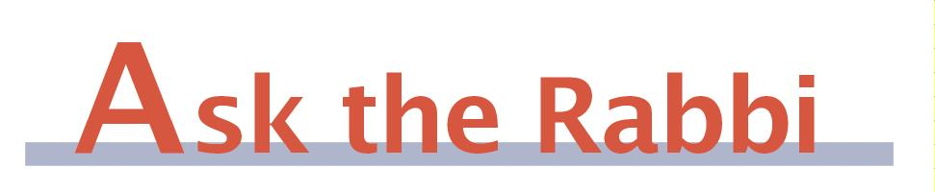

Question: What can I do when I take off my head covering on Shabbat and find hairs that are detached from my scalp and are lying on the rest of my hair? May I remove them by hand or in another manner?

Answer: Our response to this question is very uncharacteristic of our approach to halacha. We have been unable to find explicit reference to this issue. While there seem to be ample grounds to forbid it, our thought-out, researched, yet greatly intuitive, answer, despite the lack of a clear source or a clear reason, is that it is apparently permitted. Now, the explanation.
There seem to be two problems with removing the hair. Firstly, the loose hair is unwanted, and it is forbidden to remove an undesired object that is mixed in among the desired because of borer (selecting - see Orach Chayim 319). Secondly, detached hair is not part of the human body and has no clear purpose; therefore, it should be muktzeh and forbidden to handle directly.
Yet, there are strong indications (but not full proof) that neither of these issues will forbid removing the hair. The Shulchan Aruch (OC 303:27) forbids combing one’s hair normally on Shabbat because of the certainty that some hair will be uprooted from the scalp (shearing). The poskim (see Mishna Berura ad loc.: 86-87) say that one may go over the hair gently with a soft brush because it is uncertain if any hair will thereby be uprooted and it is not his intention. Poskim do not forbid the latter out of concern that if there are detached hairs on the hair, they will certainly be removed, which we hypothesized would be borer. The Shulchan Aruch (OC 316:9) also allows picking out lice or other insects from clothing or hair without the matter being considered borer. The Rama (OC 302:1), in discussing the prohibition of laundering, permits removing feathers stuck to clothes, which also would seem to be removing bad from the good and borer. Another indication is that women remove anything superfluous from the hair (including loose hairs) that could be a chatzitza before going to the mikveh, and the major sources do not limit how this should be done on Shabbat, except for the matter of combing the hair, which, as above is a problem of “shearing.”
It is harder to explain why there would not borer. Possibly, some substances or circumstances are too distant from the classic cases of borer, which refer to separating different types of food. Perhaps, removing impurities from hair and fabrics fall under the categories of shearing and laundering, and when those do not apply, borer is not a factor. Similarly, Rav S.Z. Orbach (Minchat Shlomo I, 11) suggests that since it is normal for things to get on hair and fabrics, it is considered cleaning them rather than selecting. There may be other distinctions. The exact parameters of the explanation are important because there are likely test cases that can go either way depending on the explanation. However, our relatively strong halachic intuition, based on similar precedents, is that your case is permitted.
Regarding muktzeh, in some of the sources above (including Shulchan Aruch, OC 319:9), the poskim speak of removing the apparently unusable objects directly by hand. The most likely explanation is along the lines of the Chazon Ish (47:21) that when cleaning an object from unwanted “impurities” (e.g., washing dishes) the unwanted is subsumed under the non-muktzeh and we view the action as cleaning dealing with the useable object. So here you would be considered handling your head of hair rather than grabbing detached hairs. While apparently not everyone agrees with this thesis (see Shvut Yitzchak, Muktzeh, p. 308), this does seem to be a mainstream view (see Shemirat Shabbat K’hilchata 14:(149) and Orchot Shabbat, II, 19:207 ) and other possible explanations may also cover your case.
In summary, while we can conclusively neither prove nor explain exactly why we believe one may reach into her hair and remove a detached hair, indications for permitting it far exceed those for forbidding it.

“Living the Halachic Process” - We proudly announce the publication of our first book in English. “Living the Halachic Process” a selection of answers to questions from our Ask the Rabbi project. A companion CD containing source sheets for the questions is also available.
In honor of the book’s debut we offer it at the special rate of $20 (instead of $25).
Contact us at info@eretzhemdah.org

Have a question?..... e-mail us at
info@eretzhemdah.org

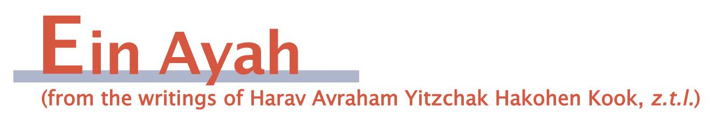
Ever Growing Spiritual Aspirations
(based on Berachot 2:66, 67)

Gemara: When the rabbis would take leave of the house of Rabbi Ami … they would say the following to him: "Your world shall you see in your life, your end in the life of the world to come, and your hope for generations to come. Your heart shall contemplate with wisdom, your mouth shall speak wisdom, and your tongue shall utter songs of praise. Your eyelids shall be straight before you, your eyes shall see the light of the Torah, and your face shall shine from the glow of the heavens. Your lips shall express knowledge, your kidneys shall be joyous in straight ways, and your feet shall run to hear the words of the atik yomin (One Who has existed for an infinite number of days).

Ein Ayah: There are different stages that are the ultimate shleimut (completeness). There is shleimut that can be grasped in the present, and there is shleimut that will come in a higher state. However, with every conception there must be an accompanying hope for something more special than that which is grasped, which makes life more pleasant. If someone reaches an unsurpassable peak, he begins to decline. There must thus be an unending shleimut, so that one will always aspire for further achievement. Therefore, in regard to the present, the gemara's blessing is that one will see his world in his lifetime with the greatest shleimut in deed and in conception. At the same time, one's end he should see in the world to come, for then there will be an even more powerful shleimut that cannot be described in this world. One's hopes will always be for something higher, so that for generations it can be striven for. This is because as time goes on and the hopes are fulfilled, it will be possible to hope for even greater, infinitely wonderful attainments, allowing constant hope and life.

The Parts of the Body as a Parable for Spiritual Completeness
(based on Berachot 2:69)

Gemara: From the above: [we will highlight each line as Rav Kook explains it]

Ein Ayah: Your eyelids shall be straight before you – the eyelids are that which hold back the power of seeing so that it does not extend to the sides at the expense of focus on that which is needed. It is a blessing that one can set the place where he can use his intellect to bring him true shleimut and not have it be scattered over matters from which he will not reap real benefits.
Your eyes shall see the light of the Torah – You will possess such a lofty level of Torah that anything you view will be in line with the Torah's view even when you have no indication from the sources regarding the case. This is what the gemara (Sukka 21b) says about the speech of talmidei chachamim, which is always educational.
Your face shall shine from the glow of the heavens – All of your physical powers will be complete and set according to the true shleimut, ready to accept the flow of wisdom.
… Your feet shall run to hear the words of the atik yomin (One Who has been around for an infinite number of days) – The loftiest conceptions of the Divine are the words of the atik yomin, things that are beyond everything that exists in the world. The idea of this blessing is that for its recipient, even the lowest elements of his shleimut will be arranged in a proper order so that he will not be missing even the smallest level and everything of his will be attached to his lofty target. That is what it means that his feet, which comprise the bottom of his body and are involved in the lowest of actions, will run to hear the words of the atik yomin. The desire to conceive the spiritual will be so great that not only will his lower elements not prevent him from shleimut but will even increase the desire to use every medium toward the goal of great shleimut.

Responsa B'mareh Habazak, Volumes I, II, III, IV, V and VI:
Answers to questions from Diaspora rabbis. The questions give expression to the unique situation that Jewish communities around the world are presently undergoing. The answers deal with a developing modern world in the way of “deracheha, darchei noam”. The books deal with the four sections of the Shulchan Aruch, while aiming to also take into consideration the “fifth section” which makes the Torah a “Torah of life”. (Shipping according to the destination)Special Price: 6 volumes of Responsa Bemareh Habazak - $75 (instead of $90)

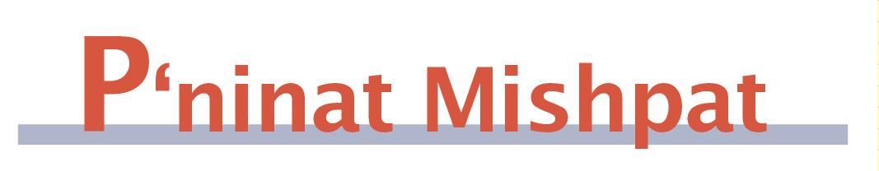

How to Elect Public Officials – part III
(based on Eit Ladun – Rav Nir Vargon - Halacha Psuka, vol. 30)

[We saw last time that a community can accept majority rule as binding even regarding civic decisions that are not mandated by Torah law.]
What is to be done when some of the constituency that is supposed to vote does not exercise this right? The Maharam says that the opinion of someone who refuses to vote is disregarded and we follow the majority of the remaining voters. The Noda B'Yehuda (I, Choshen Mishpat 20) and the Chatam Sofer (61) claim that the Maharam was discussing only a case where the non-voter kept to his refusal to vote at the time of the vote. In contrast, if the deciding people convened without the knowledge of one of the people who had a right to take part and his opinion was not heard, then the vote's results are not binding even if the decision enjoyed a large majority (which those who were left out could not have arithmetically overcome).
This idea follows from the Rashba (II, 104). He says that, in all matters, a majority is one that emanates from within the whole group after deliberation. A majority that is separate from the whole, without a deliberation that includes all, is worth nothing. The Maharit extends this limitation to votes that are done through ballot boxes and by means of someone "collecting" people’s votes. This requirement concerned many poskim, as the accepted practice was to make decisions without the presence of the entire community, and various distinctions were drawn.
The Chatam Sofer (116) says that if public announcements were made about the gathering and vote, whoever chose not to come is deemed to be like one who appointed those who did come to be proxies to decide. This is difficult, as in regard to the vote of a beit din, we would never say that one who is absent is like one who appointed the others, and the Maharit (ibid.) rejects this distinction. The Chatam Sofer must posit that while having a majority that emanates from the whole applies to public decisions as well, its parameters differ according to the nature of the decision and its forum. Beit din requires a halachic deliberation before the decision can be arrived at, and therefore the participants must actually be present. Regarding the agreement of the public, awareness and acquiescence suffices.
The Birkei Yosef (CM 13) says that only the decision of appointed officials has to include all, but decisions of the public do not require full participation. The logic seems to be that the appointees were chosen to deliberate, whereas the members of the public only have the right to take part and vote. If we were to follow this distinction today, all of the Knesset’s members would have to take part in each vote, something that rarely happens, and we would have to rely on the fact that the present system has been accepted. The optimal situation would be (as the Chazon Ish, Bava Batra 4:15 says) if all would take part in choosing representatives and all representatives would take part in the vote.

Mishpetei Shaul
Unpublished rulings by our mentor, Maran Hagaon HaRav Shaul Yisraeli zt”l
in his capacity as dayan at the Israeli Supreme Rabbinical Court.
The book includes halachic discourse with some of our generation’s greatest poskim.
The special price in honor of the new publication is $20.



Cheshvan 21-27, Baba Batra 79-85

Cancelling a Sale (83b)

Rav Ofer Livnat

This week in the Daf Hayomi the Mishna (83b) deals with the question of when a sale can be cancelled on the basis of the claim that the merchandise turned out to be different from what was agreed upon. The Mishna differentiates between a case where the merchandise was of the same kind agreed upon, but only of a different quality, and a case where the merchandise turned out to be totally different. In a case where the difference is solely in quality, only the party who was negatively impacted may cancel the sale. However, if he wishes to accept the sale despite the difference in quality, the other side may not cancel the sale. However, in a case where the merchandise turned out to be completely different, both sides may cancel the sale.
For example, if the buyer agreed to purchase high quality wheat, and the wheat turned out to be of poor quality, the buyer may renege on the sale. If the buyer wants the wheat despite the poor quality, the seller cannot renege. However, if the buyer agreed to purchase wine and the wine ended up being vinegar, both sides may renege on the sale, and, even if the buyer wants the vinegar, the seller may renege.
Until now we spoke of cases where the merchandise turned out to be different from what was agreed upon. What happens when the merchandise was as agreed upon, but the price was not appropriate for the merchandise? We learned in Baba Metzia (50b) that when there is a difference of more than a sixth between the price agreed upon and the real value of the merchandise, then the sale may be cancelled. The question is, is this case similar to a difference in quality, and only the losing side can renege, or is it similar to wine and vinegar and both sides may renege.
The Tosafot (Baba Metzia 50 d"h ve'ilu) quote two opinions regarding this question. The first opinion claims that a price difference of more than a sixth is considered to be so extreme, that it is similar to a case where the merchandise turned out to be totally different, and both sides may renege. However, the opinion of the Rivam is that only if the losing side demands a return on the price difference may the other side renege, while if the losing side wishes the sale to remain, the other side may not renege. In his opinion, a difference in price is similar to a difference in quality of the merchandise.
Rabbeinu Yona (Baba Batra 84a d"h vetana) has an intermediate opinion regarding this issue. He claims that as long as the losing side has the option to renege, the other side may renege as well. However, if the losing side has already expressed his wish that the sale stand, or if the time period which he has to renege, because of the price difference, has passed, then the other side cannot renege.

Summary and Ruling:
The Shulchan Aruch (Choshen Mishpat 227, 4) rules like the Rivam that in a case where there is a difference of more than a sixth between the real price and the price agreed upon, then only the losing side may renege on the sale. The Remma, however, quotes the opinion of Rabbeinu Yona that initially both sides may renege, but if the losing side has already expressed his wish that the sale stand, or if the time period to renege has passed, then the other side cannot renege.

Do you want to sign your contract according to Halacha?
The Rabbinical Court, “Mishpat Vehalacha BeYisrael”
Tel: (077) 215-8-215 beitdin@eretzhemdah.org Fax: (02) 537-9626

Serves the public in the matter of dispute resolution according to the Halacha
in a manner that is accepted by the law of the land.
While drawing up a contract, one can include a provision which assigns
the court jurisdiction to serve as an agreed upon arbitrator.

