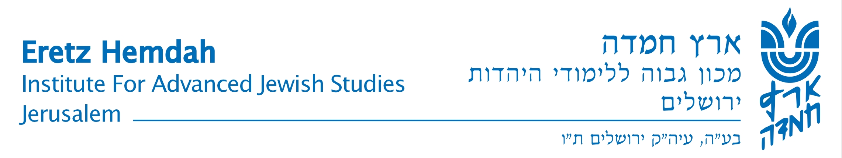

New in Katamon

Eretz Hemdah’s Friday Beit Midrash

3 Rav Chiya Street (15 Chizkiyahu Hamelech St.)

The curriculum for Kislev-Tevet 5770
(The classes are in Hebrew)

Rav Erenreich and Rav Greenberg | - | 20.11 | Kislev 3rd | Toldot | Friday – Parashat
Rav Carmel and Rav Burshtein | - | 27.11 | Kislev 10th | Vayetze
Rav Erenreich and Rav Greenberg | - | 4.12 | Kislev 17th | Vayishlach
Rav Carmel and Rav Burshtein | - | 11.12 | Kislev 24th | Vayeshev
Rav Erenreich and Rav Greenberg  Learning between 9:00 – 11:00 | - | 18.12 | Tevet 1st | Miketz
Rav Carmel and Rav Burshtein | - | 25.12 | Tevet 8th | Vayigash
Rav Erenreich and Rav Greenberg | - | 1.1.10 | Tevet 15th | Vayechi
Rav Carmel and Rav Burshtein | - | 8.1 | Tevet 22rd | Shemot
Rav Erenreich and Rav Greenberg |  | 15.1 | Tevet 29th | Va’era

Gemara class  Masechet Ktubot with Rashi – Rabbi Tzadok Elias |  | 8:15
The writings of Rabbi Kook  Rabbi Mordechai Greenberg  Rosh “Yeshivat Kerem BeYavne” | Tanach - Daniel  Rabbi Yosef Carmel  Rosh Kollel "Eretz Hemdah" | 9:00
Break and refreshments |  | 9:45
Practical Halachik Issues  Rabbi Menachem Burshtein  Rosh Machon “Puah” | Shulchan Aruch Part V- There is such a thing!  Rabbi Moshe Erenreich  Rosh Kollel "Eretz Hemdah" | 10:00
Gemara classes:  Masechet Bava Kamma with Rashi – Rabbi Hillel Bin-nun |  | 11:00

Ezrat Nashim Open

The learning at the Friday Beit Midrash is dedicated to the memory of
Rabbi Yaakov Leib zt"l, his wife the Reb. Shashke Ginendel a"h

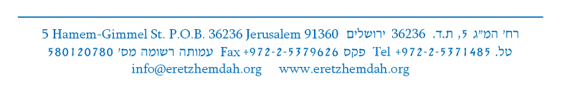
Their daughter-in-law Doris (Doba) a"h and their sons Louie and Isaac Moinester z”l

