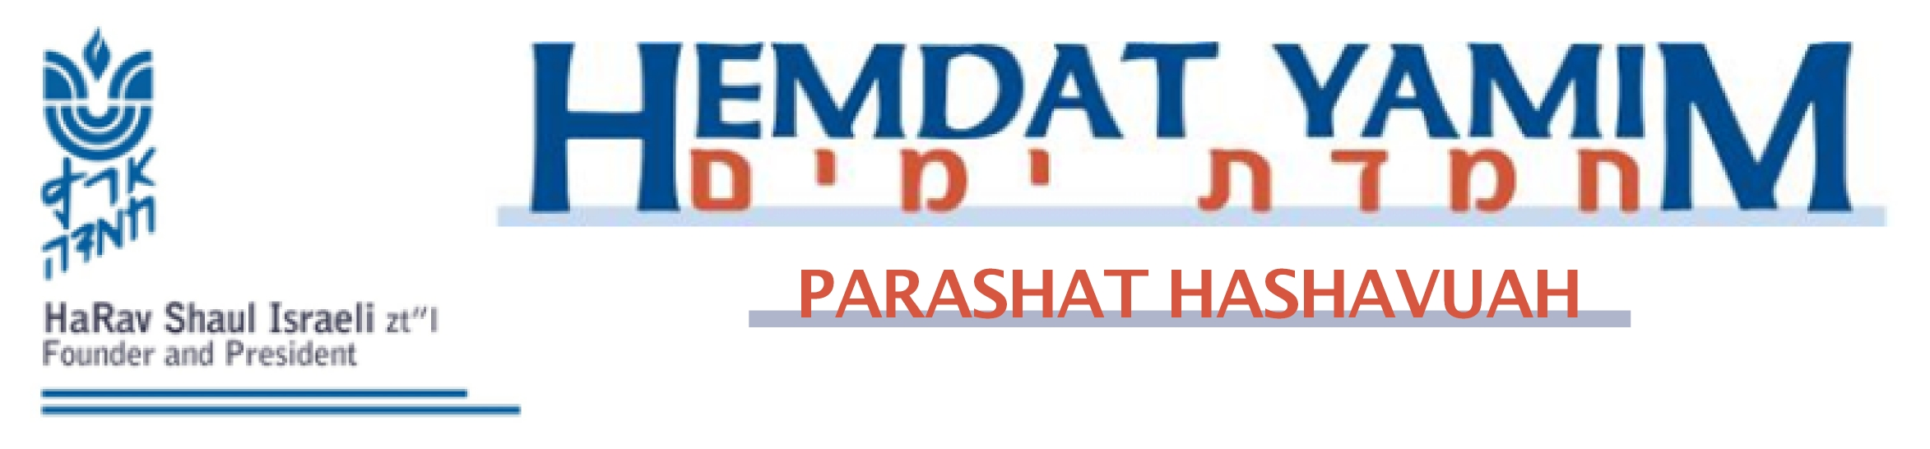

Yitro 22 Shevat 5770
A Multi-Leveled Ten Fold
Harav Yosef Carmel

At the center of Parashat Yitro is the story of the giving of the Torah, which changed the history of the world and transformed Bnei Yisrael into the am segula (roughly, the chosen nation). “If you listen to My voice and guard My covenant, you shall be for Me a segula from all of the nations, for all the land is Mine” (Shemot 19:5).
We will try to understand this great transformation based on the ideas of the first Rebbes of Ger, the Chidushei Harim, as relayed by his grandson, the Sefat Emet. Their thesis is that the Ten Sayings with which Hashem created the world were fixed by the Ten Plagues He later would inflict upon the Egyptians and enabled the great advance that came about through the Ten Commandments. The Chidushei Harim claims that this is not a mere semantic connection. Rather, it represents a fundamental spiritual process in the development of human history.
The Ten Commandments correspond to the Ten Sayings. This has to with the idea that a person first receives a yetzer hara (evil inclination), and later the yetzer hatov (good inclination) enters. First there was a world of tohu vavohu (lack of order), and the Ten Sayings were close to nature. The Ten Commandments had to come to renew the world and restore its lifeline so that it would be clear that life flows only through Hashem, through the power of Torah. This is what Chazal meant by saying that "Bereishit" hints that the world was created because of reishit (the Torah).
The first period of the world’s existence was known as the era of tohu (void), in view of the prevalent spiritual level at the time, even after the world was created with the Ten Sayings. This is parallel to the period in a person’s life before his bar mitzva, when he has only a yetzer hara, which brings him to do childish things. The yetzer hatov is still not influential, and his life follows the rules of nature without the Torah’s influence. In the realm of world history, it was premature to have tikun olam (fixing the world) by means of true free will, in which one has to work to stay away from evil and do good. Before the giving of the Torah, which is called a “potion of herbs,” physical powers ruled over mankind. The Egyptians under Pharaoh reached the nadir of spiritual levels, which we call the 49th level of impurity. According to this approach, the fact that Pharaoh had no free choice to decide what to do with Israel was not a punishment but was a natural outcome of the state of affairs before the Torah was given.
To rectify the situation, Bnei Yisrael had to be taken out of Egypt to freedom in order to elevate themselves during the 49 days of sefira from the 49 levels of impurity, and then receive the Torah on the 50th day. The Ten Plagues showed the Israelites, the Egyptians, and the world that there is a leader Who instituted the laws of nature and that one can break away from those laws of nature that keep us down.
The Torah lets us know that we have two inclinations, including a good one, which we must use to choose good. Our nation was chosen to teach the world that mankind has this power. We must use our freedom from slavery to choose properly. This is accomplished through the Ten Commandments, which show that which is good and that one must cling to Hashem.
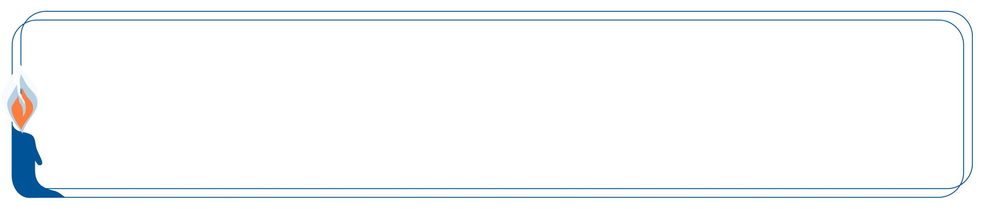
Hemdat Yamim is dedicated in memory of HaRav Professor Reuben M. Rudman o.b.m
This edition of Hemdat Yamim  is dedicated to the memory of  R ' Meir ben  Yechezkel Shraga Brachfeld  o.b.m | Hemdat Yamim is endowed by  Les & Ethel Sutker  of Chicago, Illinois  in loving memory of  Max and Mary Sutker and  Louis and Lillian Klein, z”l

Eretz Hemdah
Deans: Harav Yosef Carmel, Harav Moshe Ehrenreich
3 Rabbi Chiya Hagadol St. P.O.B 36236 Jerusalem 91360

Tel: 972-2-5371485 Fax: 972-2-5379626

Email: info@eretzhemdah.org web-site: www.eretzhemdah.org

Donations are tax deductable according to section 46 of the Israeli tax code

American Friends of Eretz Hemdah Institutions

c/o Olympian, 8 South Michigan Ave., Ste. 605, Chicago, IL 60603, USA

Our Taxpayer ID #: 36-4265359

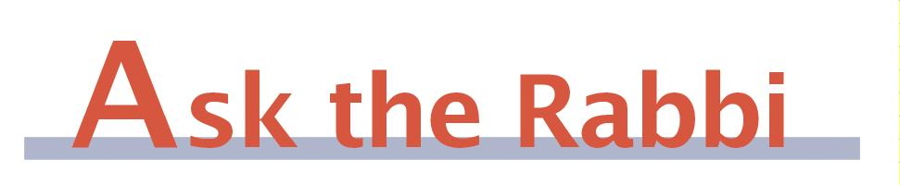

Question: My infant has conjunctivitis. A pediatrician I saw in shul on Shabbat morning suggested expressing mother’s milk directly into the eye over standard eye drops (although he was totally fine with either system or beginning treatment at night). Is that permitted on Shabbat? [Ed. note- this was answered orally on Shabbat and transcribed afterward.]

Answer: According to the great majority of authorities, human nursing, not only milking a cow, is a Torah violation, at least in many cases. We obviously allow a baby to nurse on Shabbat, but usually it is the baby who performs the very important, “problematic” act. Is it permissible for a woman to express milk for her baby’s needs, classically, or, in this case, for medicinal purposes?
It is easiest to say it is forbidden. The Shulchan Aruch (Orach Chayim 328:34) says that a nursing mother may not express milk into a cup to feed her child (it is permitted to express to relieve an oversupply in a manner that the milk is immediately lost). However, there are instances where expressing milk is permitted, which may shed light on our case.
The Shulchan Aruch (OC 328:35) rules that a woman may express milk (into the baby’s mouth - Mishna Berura 328:112) in order to interest him to nurse. Most understand that this is not a level of need that we can consider life threatening, so why is it permitted? Similarly, the Shibolei Haleket (123, see Beit Yosef, OC 328, and (slightly altered) the Rama, OC 328:35) says that a woman may not squirt someone who is under the influence of a strange malady because there is neither danger nor extreme pain. This implies that it would be permitted if there were such pain. Why?
The Magen Avraham (ad loc. 40) and Mishna Berura (ad loc.:113) explain the implied leniency by saying that this expressing is a melacha she’eina tzricha l’gufa (=mstlg), which usually means that the object that the Shabbat violation produces is not itself used in a classical, positive way. Once reduced to a rabbinic violation, it is then permitted on Shabbat to relieve significant pain (see Shabbat 107a; Ketubot 60a). While it is difficult to understand how mstlg applies there, it is hard to dismiss an approach posited by such prominent proponents, and this seems apply to our case (realize that even non-illness needs of a small child are equivalent to those of sick adults (Rama, ibid.:17)). In fact, the Kaf Hachayim (328:209) says, based on the above, that a woman may express milk into the ear of someone with a serious earache (assuming it has therapeutic value).
The Tosefet Shabbat (328:59), not seeing a mstlg in the above, suggests that expressing milk from a woman in a way other than nursing is an unusual form of mefarek, and thus rabbinic, similar to a person “nursing” from a cow (Ketubot 60a). Such reasoning would also make this case permitted. While the Mishna Berura is skeptical of this approach, the Magen Avraham’s explanation and leniency that he cited and this one are the main explanations of the Shulchan Aruch’s accepted leniency for expressing (see Sha’ar Hatziyun 81).
Other possible grounds for leniency may be related to the small amount of milk that will be expressed and the fact that it is being used immediately (see Yalkut Yosef, OC 328:(35)). This respondent has thought of at least one other novel approach that would apply to this case (but it is not sufficiently developed to share in this forum).
We have seen significant grounds to permit the pediatrician’s suggestion although it is far from unanimous (see Ketzot Hashulchan 138:30, for one; we have also spoken to important poskim whose initial reaction was to not allow it). Since the eye is an area where halacha tends to be liberal about the possibility of danger (Shulchan Aruch, ibid. 9) and we are also very careful regarding such a young baby, we would be lenient at the “bat of an eye” if there was any urgency to the suggestion. However, you indicate that other effective medicinal alternatives exist and the doctor does not think that it is of even remote importance to favor mother’s milk. Therefore, it is halachically preferable, because of doubt and because it is better to avoid the rabbinic mefarek when there are good alternatives, to not use the system of expressing mother’s milk on Shabbat.

“Living the Halachic Process” - We proudly announce the publication of our first book in English. “Living the Halachic Process” a selection of answers to questions from our Ask the Rabbi project. A companion CD containing source sheets for the questions is also available.
In honor of the book’s debut we offer it at the special rate of $20 (instead of $25).
Contact us at info@eretzhemdah.org

Have a question?..... e-mail us at
info@eretzhemdah.org

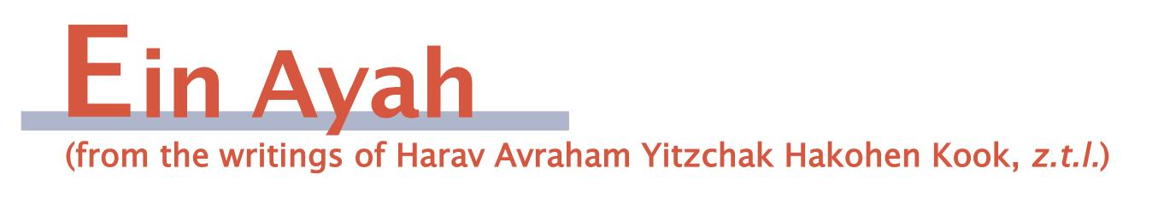

Pleasantness vs. Spiritual Life
(based on Berachot 3:34)

Gemara: One who finds sha’atnez in his clothing should remove the clothing even in the market place. What is the reason? “There is no knowledge and no wisdom and no ideas against Hashem” (Mishlei 21:30). Wherever there is a desecration of Hashem’s name, we do not give honor to the master.

Ein Ayah: Mefursamot (matters of intuitive proper behavior) should be adhered to in order to distinguish between good and bad. However, we should entrench in our minds that they are of a lower level than true muskalot (matters of ethics that need to be acquired cognitively), as the Rambam says (Moreh Nevuchim 1:2). From the knowledge of good and evil in the sphere of mefursamot comes the recognition of the pleasing and the improper. [To go from the level of sensitivity of muskalot to that of mefursamot] is what happened to Adam and Chava when they ate from the Tree of Knowledge and “knew that they were naked” (Bereishit 3:7). Therefore, the laws of Hashem’s perfect Torah, which were built on the purity of the Divine muskal, are higher than all of the rules of the mefursamot of good and bad, which include the matter of kavod haberiot (human dignity).
For this reason, when mefursamot clash with Hashem by requiring one to violate a Torah law, we are instructed: “There is no knowledge and no wisdom and no ideas against Hashem.” This is so even though mefursamot do exist and should be followed when they do not contradict Torah laws.
We should also point out that there are two types of laws. There are some laws whose purpose focuses only on the pleasing and the improper in order to broaden a person’s heart and raise his spirit by recognizing that which is pleasant and elevated and to make his talents more delicate. Included in this are matters of aesthetics. Certain areas of wisdom are not included, such as music and various forms of art. They have their own rules of culture that are arranged based on intellect. The goals of all of these fields of endeavor are not about matters that give man life, not temporary life in this world, and certainly not eternal life in the world to come. Therefore, it is proper to check all of their particular applications and origins so that nothing should go beyond the boundaries of good taste and dignity. After all, their entire purpose is to promote good taste and dignity, and thus the means by which they are obtained should not impinge on the greater goal.
There is another set of rules that have to do with life in its most fundamental basis. Regarding the rules of medicine and wellness, one should not set out to consider whether they impinge upon matters of manners and dignity. This is because their goal is of a lofty level of importance; they are encompassing, necessary, and bring completeness in a way that matters of dignity, which are extras that make things more pleasant, are not.
The laws of the Torah should be recognized as life-giving laws and not just as adding to the physical or spiritual quality of life. Rather they are needed to acquire life, both eternally and immediately; therefore, they exceed any accepted element of honor and grandeur. Consequently, wherever there is a desecration of Hashem’s name and a disregard for His Torah, which is a Torah of life, we do not give respect to the master, as things that give eternal life exceed any humanly accepted matter of honor.
P’sukim compare the Torah to medicine, as it says: “I am Hashem your healer” (Shemot 16:26); “It [the Torah] will be medicinal for your navel” (Mishlei 3:8); “as I cure Israel, and the sin of Ephrayim will be exposed” (Hoshea 7:1). Regarding the last pasuk, it is undignified to reveal sin; however, whenever there is a medical need to do so, a doctor must disregard dignity and manners. Therefore, Hashem felt it necessary to reveal the sin of Ephrayim, as He was only concerned that salvation will come to those who need healing.

Responsa B'mareh Habazak, Volumes I, II, III, IV, V and VI:
Answers to questions from Diaspora rabbis. The questions give expression to the unique situation that Jewish communities around the world are presently undergoing. The answers deal with a developing modern world in the way of “deracheha, darchei noam”. The books deal with the four sections of the Shulchan Aruch, while aiming to also take into consideration the “fifth section” which makes the Torah a “Torah of life”. (Shipping according to the destination)Special Price: 6 volumes of Responsa Bemareh Habazak - $75 (instead of $90)

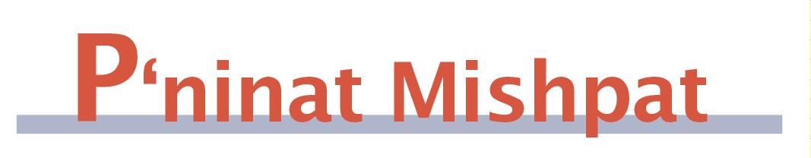

Medical Malpractice – part I
(based on Eit Ladun – Rav Nir Vargon, Rav Itamar Blaugrond - Halacha Psuka, vol. 34)

We have discussed the culpability of people who gave bad financial advice, seeing the distinctions in their levels of proficiency in the field at hand and the matter of whether they were paid for their services (which makes one more culpable). The rules, though, are somewhat different regarding medical mistakes (malpractice, as we call it).
The Shulchan Aruch (Yoreh Deah 336:1-2) says: “One should not deal with medicine unless he is an expert and there is no one greater than he [in the place], for if he does not act so, he is like one who spills blood. If he did try to heal someone without the court’s permission, he is obligated to pay for damages, even if he is an expert. If he tried to heal with permission and made a mistake that caused damage, he is exempt from paying in the courts but has an obligation to the Heaven [a moral obligation to pay]. If he killed and it is known that he did so by negligence, he goes to exile as a result. A doctor may not take pay for the knowledge and education he possesses, but he may be paid for his toil and his refraining from other work.”
We see then that one factor regarding a doctor’s culpability is receiving authorization. Neither the level of his expertise nor the matter of whether he was to be paid impacts on whether he has to pay for his mistake. (The latter may be because he may not receive a standard type of payment.) Nowadays, permission of the court is replaced by a government-sponsored license (Aruch Hashulchan, YD 336:2).
The Ramban gives the following explanation for the impact of the court’s permission on the doctor’s exemption. The gemara (Bava Kama 85a) sees in “he shall certainly heal” (Shemot 21:19) the source that a doctor was given permission to heal. He explains this is necessary so that a doctor should not say: “Why do I need this headache? Maybe I will accidentally kill someone.” However, the Ramban was troubled by the fact that since the Tosefta says that a doctor who killed by accident has to go to exile, we see he is liable. He posits that a doctor is like a dayan (rabbinic judge) who is exempt from standard errors (“a dayan has only what his eyes see”). Thus, the Torah was interested in encouraging people to be involved in both professions and exempted them from actual payment as long as they had permission and did not act negligently.
Harav Yaakov Ariel (Ohala Shel Torah I, 55) questions the Ramban on where do we see a special exemption for a doctor. After all, if he is an expert and is not paid (as he is not supposed to be), he is anyway exempt just by following the regular rules of craftsmen (Bava Kama 99b). He answers that it is talking about a case where he took money to heal, and thus as a craftsman, he should be obligated to pay. The Rabbis exempted him in order that society would function more smoothly. Even though nowadays doctors are paid enough that they will continue to serve as doctors even if they could be sued like any other worker, Harav Ariel says that the logic to encourage them in this way still continues.

Mishpetei Shaul
Unpublished rulings by our mentor, Maran Hagaon HaRav Shaul Yisraeli zt”l
in his capacity as dayan at the Israeli Supreme Rabbinical Court.
The book includes halachic discourse with some of our generation’s greatest poskim.
The special price in honor of the new publication is $20.

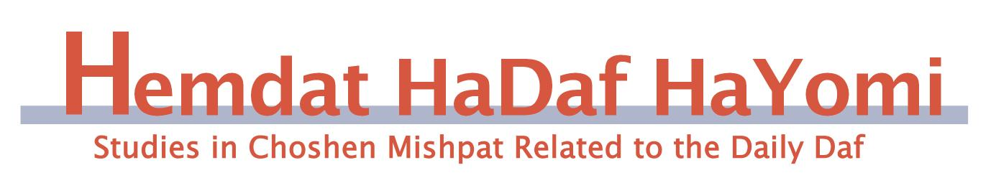
Shevat 16-22, Bava Batra 163-169

Writing Down the Claims of the Litigants (168a)

Rav Ofer Livnat

This week in the Daf Hayomi we are learning the Halachot of shtarot. One type of shtar that is mentioned in the Mishna (167b) is a "shtar berurin." The Mishna states that a shtar berurin can be written only with the agreement of both sides. The Gemara (168a) offers two explanations as to what the role of this shtar is. One explanation is that it is a shtar in which the claims of both litigants are recorded. According to this, the claims of the litigants cannot be written without their agreement. We will try to explain what the significance of writing down the claims is.
The Rashbam (d"h shitrei ta'anta) explains that the scribe of the judges would write down the claims of the litigants, so that they would not be able to change their claims afterward. The Nimukei Yosef (78a in the pages of the Rif) further explains that although we learnt (Baba Batra 31a) that a litigant can change his claims as long as he wasn't contradicted by witnesses, or even after he was contradicted, if he can explain that this was his original intent, after the claims are written down, they cannot be changed. According to this, it is clear why the claims can be written only after the litigants have given their consent.
We see from this discussion that the assumption is that the litigants stand before the judges and orally state their claims. The Rivash (298) states that this is indeed the Halacha: "The judges should hear the claims of the litigants from their mouths, because they might be able to learn from their words which one is telling the truth, and they should not come with their claims organized by someone else, with lies embellished by sophisticated language." In other words, when the claims are stated orally, the judges have a greater chance of finding out the truth.

Summary and Ruling:
The Shulchan Aruch (Choshen Mishpat 13, 3) rules that the judges must hear the claims of the litigants from their mouths and afterwards, with their consent, have the judge's scribe write their claims. After the claims have been written down they cannot be changed (80, 2). The Remmah (13, 3) adds that if both litigants wish to submit their claims in writing, they may.

Do you want to sign your contract according to Halacha?
The Rabbinical Court, “Mishpat Vehalacha BeYisrael”
Tel: (077) 215-8-215 beitdin@eretzhemdah.org Fax: (02) 537-9626

Serves the public in the matter of dispute resolution according to the Halacha
in a manner that is accepted by the law of the land.
While drawing up a contract, one can include a provision which assigns
the court jurisdiction to serve as an agreed upon arbitrator.

Eretz Hemdah is the premier institution
for training young rabbis to take the Israeli Rabbinate's
rigorous Yadin Yadin examinations.
Eretz Hemdah, with its distinctive blend of Religious Zionist philosophy
and scholarship combined with community service, ensures that its graduates emerge with the finest training, the noblest motivations
resulting in an exceptionally strong connection to
Jewish communities worldwide.

